A Kentish Man Returns

24 August-2 September 2017

J R Garner

INTRODUCTION
The Skipper was born in Kent, west of the River Medway, which makes him a “Kentish Man” as opposed to a “Man of Kent” (Those born east of the Medway; they’re a bit weird!). When he was 6 his father bought a small lugsail dinghy. The dinghy was kept on the Medway, initially at Maidstone but after the first year or two on the tidal part at Snodland and later Cuxton.
The furthest down river we ever went was Rochester. For several years that was our annual Whitmonday outing (Spring Bank Holiday for the younger readers!). Father and older brother and sister would sail down to the floating landing stage just below Rochester bridge. Mother would take younger brother and I on the bus (we did not have a car in those days). We would picnic and sail a bit or go round the castle before returning home. I had never sailed downstream of Rochester or in the Medway estuary.
We decided that in 2017 we would make an overseas voyage in Makeda, our Iroquois catamaran, ie. across the great moat that divides Essex from Kent. The objective was to explore the estuary, visit the Chatham Dockyard Museum and also the Swale that divides the Isle of Sheppey from the mainland. The only bit of the Swale I knew was the short stretch around Harty Ferry in the east Swale. The lugsail dinghy was kept there during the last two summers before I left college, because by then my parents had a car and I could drive myself. We did also wonder if we could find our way up the creek to Faversham. Skipper and Mate lived on the south edge of Faversham for the first two years after we married but at that time we did not have a useable dinghy.
Tides around August Bank Holiday looked suitable for the trip. At the last minute we reversed the planned order of exploration because Kelvin, our Cruising Secretary, mentioned he was going to take his Moody 28 to a Moody rally at Chatham Marina over the bank holiday. We decided to plan our arrival there after the bank holiday crowds had left.

THE VOYAGE
Captain: Jerry Garner
Mate: Margaret Garner
Thursday 24 August
HW Harwich 1421
1440 Left our mooring at Manningtree. Engine off after Hook and we sailed goose-winged before a westerly breeze, force 3-4. Weather fair and warm.
1550 Erwarton Post.
1640 Moored in Shotley Marina, G pontoon. The reason for paying marina fees instead of anchoring for free off Erwarton was to use their hose to scrub off the accumulated bird muck from our feathered friends at Manningtree.
1800 Inshore Waters forecast: Mainly SW becoming variable 3 or less, inc. 4 at times. Smooth/slight, fair, good.

Friday 25 August
HW Harwich 1457
0600 Inshore Waters forecast: Variable 3 or less becoming mainly E or SE 3-4 for a time later. Smooth or slight, fair, good.
0840 In the lock. Once clear of the marina we motored with the main hoisted – no wind, hazy sunshine.
0908 Harwich Shelf. Motoring on in a glassy calm.
0954 Stone Banks buoy. Put “Birdie”, our autopilot on. It’s called Birdie because of the little cheeping noises it makes as it steers.
1030 Off Walton pier. We tried using the ghoster (a lightweight genoa, set flying using the spinnaker halyard) but the light wind was too much on the nose. Headed offshore to avoid the Clacton Air Show “no go” area.
1110 Ghoster set off Great Holland. Engine off. Knoll buoy bears 239deg. 7.1 miles. Switched fuel tanks as the smaller 12 litre tank was now very low.
1125 Wind too much on the nose; engine back on.
1150 Engine off. Genoa plus main, close-hauled on port tack. Tracking 245deg. Knoll bears 240deg. 4.29 miles.
1200 Inshore Waters forecast: Variable 3 or less, occ. 4 at first. Smooth. Occasional rain later. Good occ. moderate later.
1320 Half a mile to Colne Point buoy. Just had a Red Arrows display astern, over Clacton.
1326 Rounded Colne Point.
1425 Anchored just inside Pyefleet. On the Mersea side of the channel.
1515 Phoned Iron Wharf boatyard, Faversham. Should have a berth for us Sunday afternoon but advised to phone first before starting up the creek.
Rested. The Romford Navy (fleet of jet-skis) was out in force so a bit noisy. Later the skipper entered waypoints in GPS for the route to the Swale.
1800 Inshore Waters forecast: Variable 3 or less, occ. 4 at first. Smooth occ. slight at first. Rain or showers later. Mod. or good.
It’s been a nice breeze ever since we arrived. Kelvin in Circe probably did well going direct from Shotley to Medway today.

Saturday 26 August
HW Dover 1502 Harwich 1558
A quiet night.
0600 Inshore Waters forecast: Variable 3 or less, increasing 4 at times. Smooth/slight. Showers for a time at first. Moderate/Good.
0825 Weighed anchor. Mainsail plus engine. While washing the anchor the head of the new mop unscrewed and was lost!
0907 Colne Point buoy. Still motoring.
0929 Colne Bar buoy. ‘’ “
0943 Eagle buoy. “ “
1018 Wallet Spitway buoy to port.
1024 Set genoa but still motoring. Birdie now steering to free up the skipper for navigation checks.
1033 Cleared the Swin Spitway. Engine off as the tide is now in our favour.
1049 Inner Whitaker buoy abeam to starboard. Making 4 knots plus, close-hauled on port tack. We are now going down the Middle Deep between the Barrow and the Foulness Sand.
1110 Maplin Approach buoy to starboard. Birdie still coping well even though close-hauled.
1131 East Maplin buoy. Tacked. We are now tacking down the West Swin against this light wind.
1200 Inshore Waters forecast: Variable 3 or less. Fair, occasional rain.
1250 Passed west of Maplin Edge buoy on starboard tack.
1322 Maplin buoy to port.
1353 Blacktail Spit buoy, on the south-east corner of the Maplin sands, abeam to starboard.
1443 Tacks not getting us any nearer to Kent! Tide now slack and we are making across it anyway. Engine on and jib furled. Set direct course for the Columbine buoy off Whitstable. This took us west of the Red Sands towers and across the Oaze Deep, the main shipping channel. At least, with the engine we were able to dodge round the stern of ships that looked too close.
1510 East Cant buoy. Steering 140deg. Saw a porpoise.
1520 Engine off and full sail heading for the Columbine Spit buoy which marks the entrance to the Swale.
1632 Rounded Columbine Spit buoy.
1654 Pollard Spit buoy. Now running goose-winged, steered by Birdie. Passing the Horse Sands in the entrance to the Swale.
1745 Sand End buoy. We sailed on past the entrance to Faversham Creek and picked up a mooring belonging to Conyer Cruising Club, off Harty Ferry, on the south side of the Swale.
On the whole voyage, apart from 2-3 Thames barges, we were the only yacht actually sailing. Most were motoring without a sail up. The first sailing seen was in the Swale!
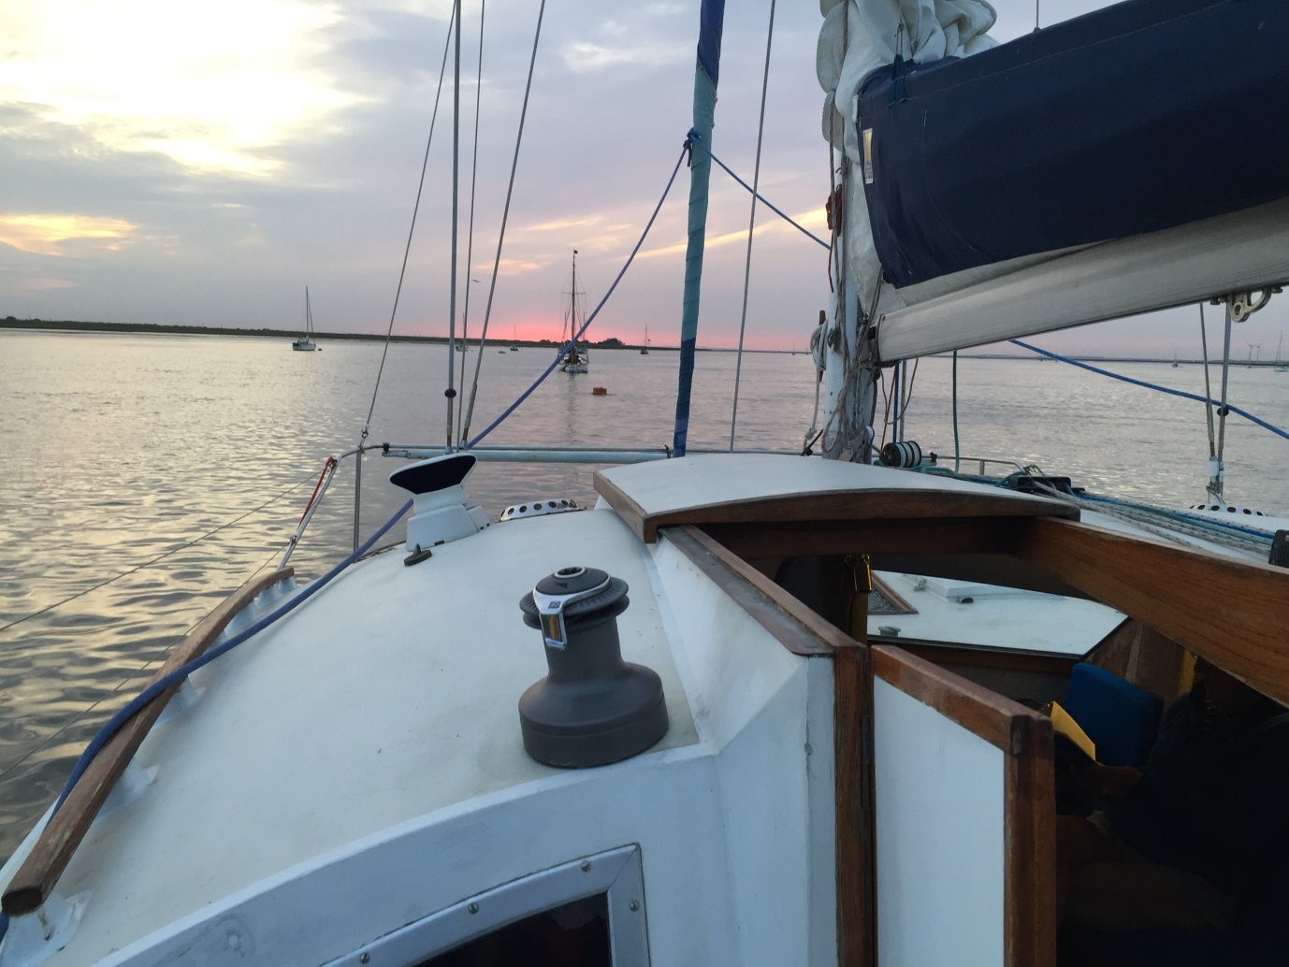
Sunset at Harty Ferry

