**Sunday 27 August**

HW Dover 1545

0800 A leisurely breakfast. Weather warm and sunny but a bit misty.

Mate cleaned the cabin floor, the main dirt being bits of feather brought in on our shoes, thanks to those Manningtree birds. Skipper checked the petrol tanks and “end for ended” the port jibsheet which was showing signs of chafe. Then we sat in the cockpit and read books. After lunch we phoned the skipper’s brother, John, who has a farm near Faversham and arranged to meet tomorrow. Saw 2 small hovercraft visit the Ferry House Inn on the north shore, driving up the mud. Sunbathed.

1502 Left mooring and motored up Faversham Creek. This narrow winding creek is fairly well buoyed but don’t follow a straight line between them, allow for the curves of the creek.

1600 Moored at Iron Wharf between the Thames barge *Mirosa* and a floating dock containing a motor yacht being refurbished. One of the men who helped us moor gave the skipper a lift in to Faversham to buy some petrol as all our motoring has left us rather short.

In the evening, once *Makeda* had settled on the mud, we walked the footpaths to Standard Quay and around the area which was once the old abbey. Never been there in the 2 years we lived in Faversham!

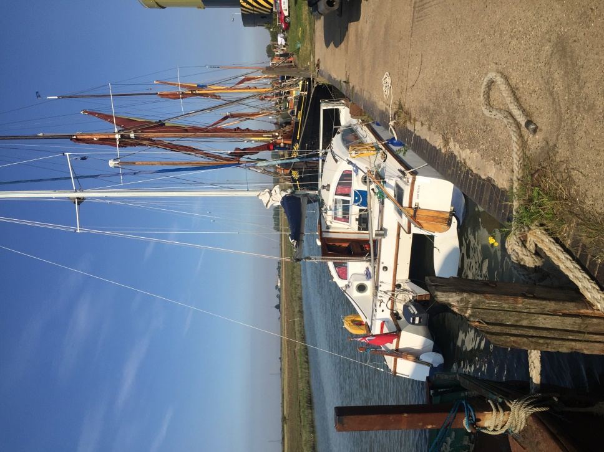

Makeda alongside at Iron Wharf boatyard

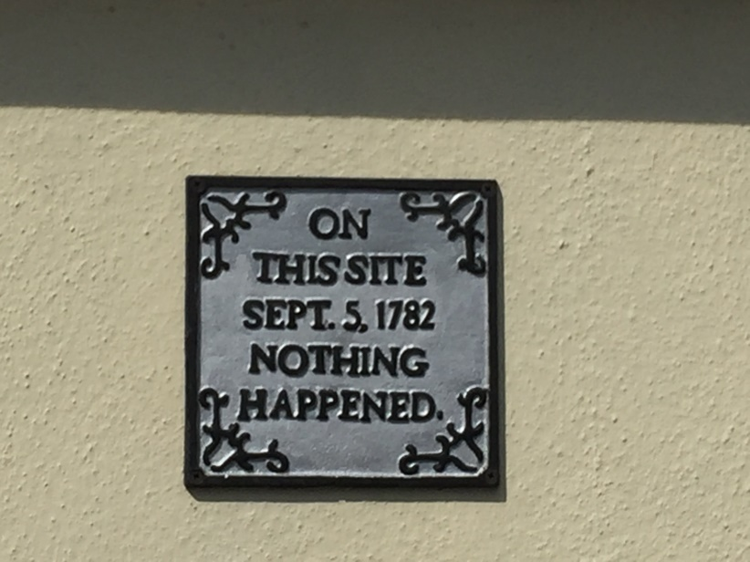

There are many historic buildings in Faversham!

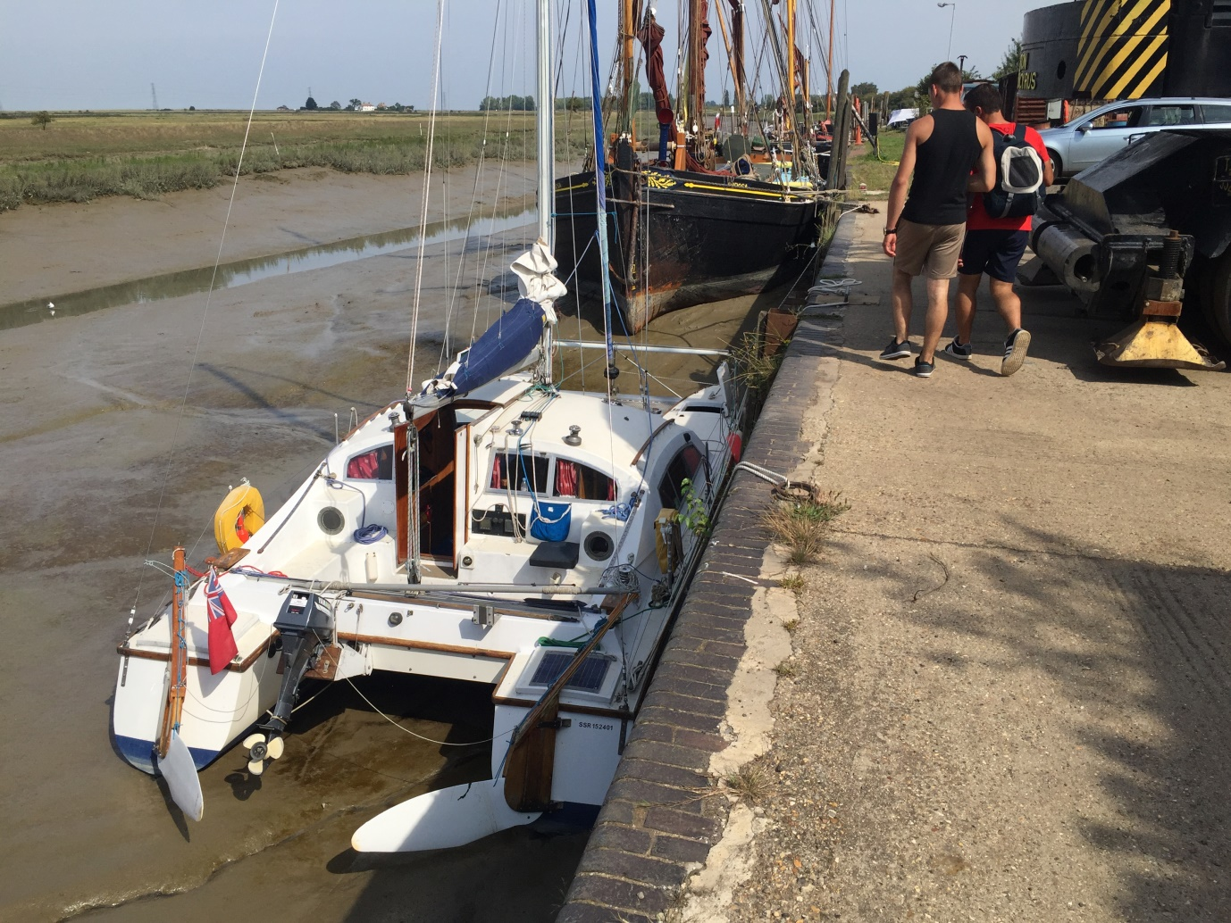

Low tide at Faversham

**Monday 28 August**

HW Dover 1630 Harty Ferry 1755

Used the boatyard showers and then had breakfast.

0930 John and his wife Marina arrived and both managed to get down the vertical ladder to get aboard (Their beautiful clothing did gain some streaks of mud!). Had a long chat over coffee. John had brought a 2 gallon can of petrol at skippers request, so that was emptied into the tank. They then took us both in their car to Morrisons, where we shopped for provisions. Then they dropped us off to walk back via Abbey Street and Standard Quay.

Paid the yard £10 for the one night berth.

Had a snooze after lunch then walked to Standard Quay for ice-cream and skipper looked at the “Cambria Trust’s” photo collection. The *Cambria* was the last Thames barge to trade under sail with no engine and was restored at Faversham.

1600 Mooring warps singled up. Just waiting for water.

1610 Left Iron Wharf and motored down Faversham Creek. Very hot in spite of a breeze.

1700 Out of the creek and reaching in a SW3 breeze. Very hot and sunny.

1715 Anchored on the south shore between Fowley Spit and Uplees.

1800 Inshore Waters forecast: SE veering W becoming variable later 3-4, then becoming N or NE 4-5. Occasional rain later. Moderate/Good occasionally Poor.

Had a nice evening meal with a bottle of Rioja! A quiet night once the Bank Holiday motor boats had gone home.

**Tuesday 29 August**

HW Dover 1720 HW Queenborough 1855

0600 Inshore Waters forecast: Variable 3-4 occasionally 2 at first, becoming N 4-5 later. Thundery rain later in SE. Moderate/good.

0730 Glassy calm at the moment. I think we chose the right anchorage; looking west there are at least 4 yachts crammed in the spot off Conyer recommended by the pilot books.

0930 Hoisted main, started engine and weighed anchor. Heading west against the tide and a westerly force 1 breeze. Warm and sunny.

Fowley Island, just before Conyer Creek, is really just the part of a large muddy shoal that shows above high water. The Swale is over a mile wide from here to Milton Creek but at low water is narrower than the Stour below Mistley is. However, it is well buoyed though we needed to check off each buoy to know which one was coming up next.

0953 No.2 PHB, 1002 No.4 PHB, 1013 No.6 PHB (water still glassy), 1019 No.8, 1030 No.10, 1034 Elmley SHB, 1037 North Ferry SHB.

1044 Lilies South Cardinal Buoy. The Swale bends northward here. Called up Kingsferry bridge on VHF. We were told it would be raised at ten past the hour ie. after the next train.

The lateral buoyage changes here, where the tides meet. We now had to leave the SHBs to port.

1057 S10, 1102 S8, 1103 Ridham Dock to port.

1116 Passed under the old Kingsferry road/rail bridge, lifted just for us! Caused a traffic tailback. Although the main road to the island uses the new high level bridge, the old bridge is still used by local traffic.

1126 Passed S7 PHB. The breeze has filled in from the north; dead ahead so still motor sailing.

1136 S5 SHB to port.

1155 Passing Queenborough all-tide-landing and the yacht club.

1200 Inshore Waters forecast: Variable 3-4, occasionally 2 at first becoming N 5-7 later. Occasional drizzle, thundery rain later. Moderate/poor occasionally good for a time. ie. Take your pick!

1210 Bore off round Queenborough Spit into the Medway. Set part-rolled jib and turned off the engine. Had lunch.

1245 Lowered sail at Stangate Spit buoy and turned south into Stangate Creek. Instead of following this creek all the way up to where there are moorings we turned west into Sharfleet creek which runs behind Burntwick Island and, at high water, rejoins the Medway. This wide meandering creek is a bit like Horsey Mere (Walton Backwaters) but a lot deeper. We anchored at 1306, near low water, in 2 metres. Very hot. The other side of the Medway, visible over the low-lying Burntwick Island, was the Thamesport container terminal but with only 2 medium sized ships there it was not like being in Shotley opposite Felixstowe.

We sunbathed then had a swim round the boat but, though the water was nice, the tide was a bit strong so we came out and sunbathed a bit more.

1800 Inshore Waters forecast: See above!

1900 Clouded over now but still warm. Two other yachts have anchored here but are well away from us. A very peaceful spot (except for some jet-skis this afternoon).

Blew hard all night – noisy but no waves.

**Wednesday30 August**

HW Dover1820 Queenborough 1955

0600 Inshore Waters forecast: N backing NW4-5 occasionally 6 at first in SE, backing W3-4 later. Rain at times fair later, Mod/good.

0915 Weighed anchor and motored out of the creek. Set sail once past Stangate Spit buoy.

0945 No.14 buoy, west end of Burntwick Island. Full main and part-rolled jib.

1026 No.22 at the end of Long Reach, opposite the old Kingsnorth jetty.

1054 Off Gillingham Marina. The port hand buoys had all been even numbers so far. The pilot books advise to call Chatham Marina when you get to buoy 32. So at the next red buoy after 30 I did so, only to find it was 30A! So it took a bit longer to reach the marina entrance than expected. Luckily the lock was still open for us.

Chatham Maritime Marina is in what was No.1 Basin of the Naval dockyard. The entrance lock is deep and narrow. With the wind funnelling in from astern we accelerated after putting the engine in neutral; it stalled when put slow astern so our entry was a bit crab-like “lasso a bollard”!

1150 Moored in berth 7A.

In the afternoon we explored to find the whereabouts of the pub and the convenience store/cashpoint. Then on to the Chatham Maritime Museum which is in many of the old dockyard buildings and dry-docks. We concentrated on the indoor displays relating to the history of the dockyard and naval ships from Stuart times to the 1960s. There were also workshops where we could see how they managed such tasks as pipe bending. There was also a collection of RNLI lifeboats; from some of the earliest rowing boats through to the modern day high speed vessels and RIBs etc. Another building housed a museum of Royal Engineers specialised vehicles and equipment (The Royal Engineers main base and training centre is at Gordon Barracks, Gillingham).

Having returned to *Makeda* to rest and smarten up, we went out for a meal at the “Ship & Trades” pub. This was a modern chain pub, much of the area around the old dock basins is now a retail park plus some tower blocks of flats. The meal was good by pub standards but mediocre by restaurant standards. Bought milk and bread at the Co-Op convenience store on the way back.

That night we found the cabin lights were playing up due to low voltage in the battery.

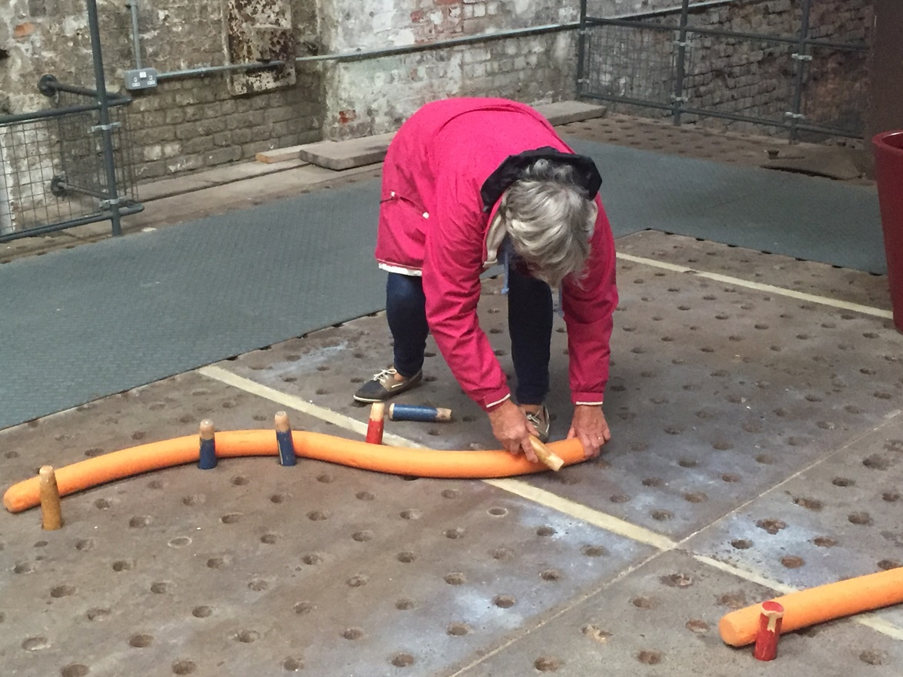

Margaret tries her hand at pipe bending!

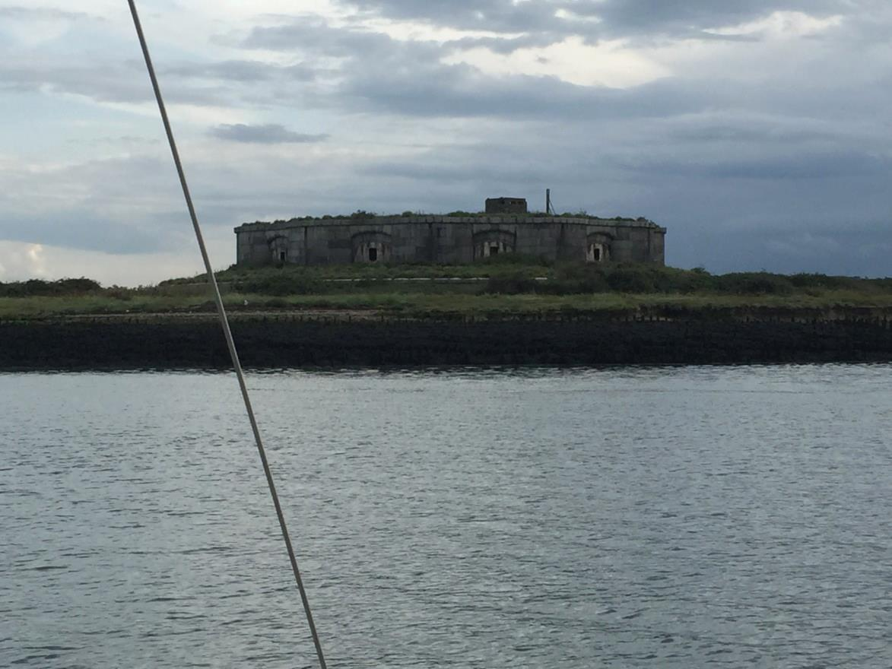

One of the forts built to protect this major Naval base

**Thursday 31 August**

HW Dover 0657 Queenborough 0832/2107

After breakfast we connected the battery charger to shore power and also filled the water tanks.

1000 Went to the museum again (the entry ticket lasts a year as there is more there than you can see in a day). We went to the Ropery where a woman in period dress showed us how they used to prepare the hemp and make the ropes. They still make hemp ropes commercially here. There is demand from historic ships and also film companies (even Pirates of the Carribean wouldn’t look right if they were pulling on polyester ropes!). Next we went aboard the submarine HMS Ocelot in one of the dry docks. Even though one of the last conventional submarines built, in the 1960s, she was still amazingly cramped. We have more cabin space on *Makeda*! Finally we went aboard HMS Gannet, a corvette built in 1878. Square-rigged and clipper bowed but with a steam engine and lifting propeller. (One startling thought: my paternal grandmother was born 4 years after this ship was launched yet, by the time she died, there had been 2 world wars and men had walked on the moon!)

After returning to *Makeda* for lunch we unplugged the shore power and got ready to leave but all the electrics: GPS, depth-sounder etc. were u/s due to low voltage. Most annoying because there had been an expensive overhaul of the electrical system last winter, including new charger, voltage controller and 2 new batteries. The marina office gave us the mobile phone number of an electrician, who was luckily working elsewhere in the marina. He diagnosed that the 100 amp/hr main battery was dud. He was able to return with a brand new battery later that afternoon.

1630 In marina lock. Motored on down river. Wind very variable.

1728 Darnett, No.23 green buoy. This is east of Hoo. So many of these Medway towns and villages have strange names. I have already mentioned Snodland and Cuxton, there is also Strood. Funnily enough, these are all on the west bank; perhaps it’s not just the Men of Kent that are weird!

1743 Set jib and turned engine off but only in order to switch fuel tanks. Engine re-started.

1754 Green No.15 buoy, close to Oakham Ness jetty.

1800 Inshore Waters forecast: Variable becoming NE 3-4 later, decreasing 2 at times. Thundery showers. Good occ. poor.

1806 No.14 red buoy, west corner of Burntwick Island.

1840 Anchored in Sharfleet Creek as before.

**Friday 1 September**

HW Harwich 0823/2110

0600 Inshore Waters forecast: Variable becoming N/NE 3-4 occ. 5 later. Smooth/slight. Showers, thundery at first. Good, occ. poor at first.

A fine but chilly morning. Wind currently SW3.

0735 Weighed anchor and motored out of creek.

0745 Hoisted main at Stangate Spit buoy and bore off under full sail. Course 062deg.

0804 Victoria starboard hand buoy close to starboard. Yachts are supposed to avoid the dredged ship channel marked by the buoys. Course changed to 040deg. Birdie now on the helm.

0826 Grain Hard buoy, opposite Garrison Point.

0838 Grain Edge buoy to port.

0852 No.9 green buoy. Wind now light so engine on. We passed close south of the wreck of the Montgomery which is clearly marked by several yellow buoys. This was a Liberty ship loaded with ammunition to be delivered to Normandy beach-head soon after D-day. While waiting for the convoy to form she dragged anchor onto the Middle Sand (the corner between Thames and Medway) and broke her back. Because of the unstable nature of the cargo it has always been considered too risky to try any salvage. Apparently, if it did blow up, most of Sheerness would be demolished!

0902 No.7 green buoy close to starboard.

0930 No.1 “ “ “ “

The breeze has now filled in from the NNE. We are pointing as close as possible, tracking 071deg. Engine still on as we are crossing a busy shipping lane.

0956 We have crossed the shipping lane and are past Sea Reach No.1 buoy. Engine off. Track 075 deg. 5-6 knots.

1022 North Oaze buoy to starboard.

1026 Tacked. Track now 331 deg.

1045 Tacked near Blacktail Spit buoy. Tracking 072 deg.

1114 Tacked at SW Barrow buoy. First attempt failed as the tie for the top batten and its associated tell-tail had tied itself to the backstay. Had to part-lower the main to free it. (The tie has now been modified to avoid this problem in future!) Track 322 deg.

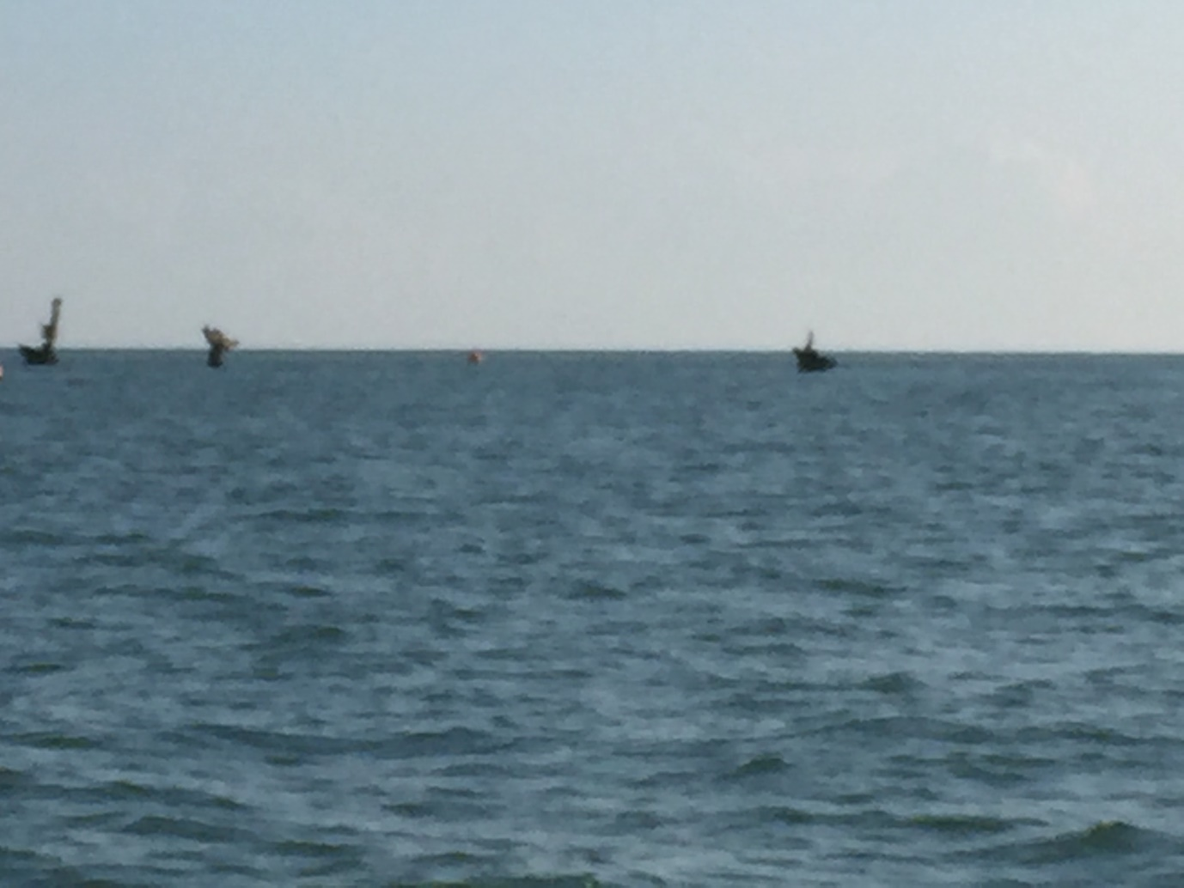

The masts of the Montgomery - Keep clear!

1130 Tacked. Track 072 deg.

1142 Maplin buoy to port.

1155 Tacked. Track 322 deg. 1207 Tacked on to 068 deg.

1221 Maplin Edge buoy abeam to port. 1230 Maplin Bank to starboard.

1245 Maplin Middle to port. Now tracking 044 deg.

1310 Wind becoming lighter and a bit variable.

1325 Engine on as wind dropped.

1338 Rounded Maplin Approach buoy. Heading NNW for the Swin Spitway.

1400 Inner Whitacre to port. Crew stripped in hot sun. The Gunfleet wind farm is stationary but some shore windmills at Clacton are turning – a sea breeze?

1418 Swin Spitway buoy to port. Hot!

1435 Wallet Spitway buoy. Heading for the Colne.

1455 Light NW breeze, dead ahead!

1507 Knoll buoy abeam to starboard. The breeze is now a moderate North-Westerly. We contemplated changing course to go up the Wallet to Harwich (though it would be against the tide). Luckily we used the binoculars and the yachts off Clacton appeared to have little breeze and from different directions.

1540 Colne Bar buoy. Breeze dead ahead.

1606 Colne Point to starboard. Wind freshening from NW. We sailed the last bit to Mersea Stone with the engine on tickover.

1645 Anchored in the Pyefleet, just as it poured with rain.

**Saturday 2 September**

HW Harwich 2216

0600 Inshore Waters forecast: NE becoming variable 3-4 dec. 2 at times then becoming S3-4 occ. 5 later. Thundery showers at first. Good occ. poor at first.

0835 Weighed anchor. Engine plus full sail. Lots of barges, smacks etc anchored in the Colne, possibly for a barge match (?)

0908 Still motoring out. Warm and sunny. Very light wind from astern.

We turned the engine off at Colne Point and turned east. Making 4 knots over the ground. Wind very variable, mainly NE about force 3, so Birdie had to be retired. Made good progress on port tack.

1108 Tacked near north end of Gunfleet wind farm.

1144 Tacked off Great Holland.

1200 Inshore Waters forecast: Variable 3-4 dec 2 at times, becoming S3-4 occ. 5 later. Showers at first then mainly fair. Good occ. moderate.

1215 Tacked. Wind has gone very light and fluky.

Had lunch. Wind still very light.

1320 Medusa buoy. 1353 Stone Banks buoy.

1418 Engine on and jib furled. After a brief squall the wind is again very light.

1440 Landguard buoy.

1504 Harwich Shelf. Bore off into Stour. Mate encouraged skipper to try the spinnaker but the light and variable wind caused the main to gybe and the spinnaker to flop and tangle. Carried on under engine!

1640 Anchored off “Strandlands” just east of Wrabness.

We expected to spend the night here as, by the time the tide would let us reach our mooring it would be dark. We opened the last tin of provisions; labelled chilli con carne. The tin contained frankfurter sausages; not the same thing at all!

The evening turned out to be very clear and bright so we decided we could make it to our mooring.

1900 Weighed anchor and motored up river and round by Mistley Quay.

2030 Just able to reach our mooring; though the rudders were ploughing through the mud. The dinghy had managed to wrap itself round the mooring while we were away, which took a bit of sorting out.

A quick packing and we departed for shore in the dark.