A dramatic sailing holiday among the volcanic Aeolian Islands off the northeast coast of Sicily.

Six of us ancient mariners met up at Stansted and flew to Palermo in Sicily where we spent a couple of days sightseeing before driving to Portorosa Marina on the north east coast of Sicily to join our charter boat ‘ Agata’ a 51 foot Bavaria sailing cruiser.

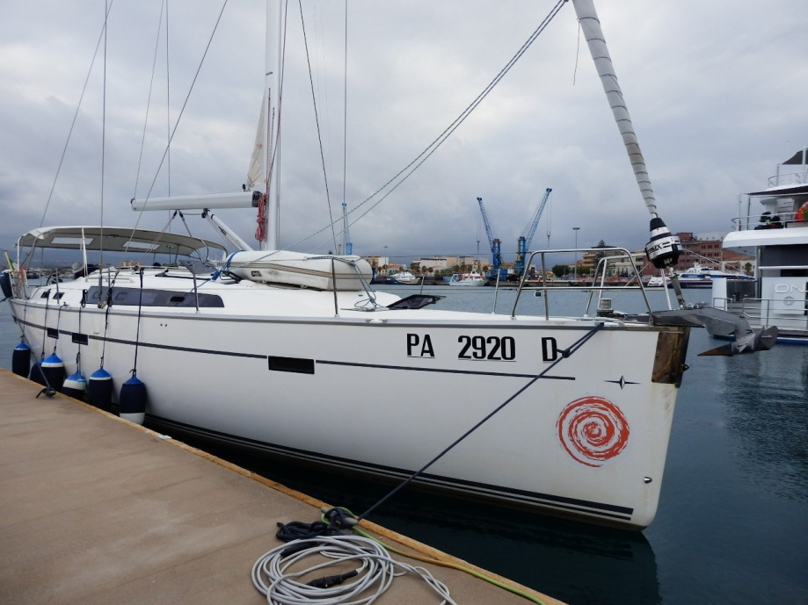

Day 1 Destination Milazzo

Arriving at 16.00 hrs we spent the first night in the marina then had a fine sail the following morning along the coast to Milazzo where there was a sheltered berth in the busy harbour close to the town centre and where we could stock up with stores from a nearby supermarket and eat ashore in a fine seafood restaurant on the waterfront in the evening.

Day 2 Destination Panarea

Next morning was warm, bright and a fair breeze to take us towards our next destination, consisting of the Aeolian islands a group of 8 volcanic islands all within a days sail of each other.

We passed the islands of Lipari and Vulcano and headed for Panarea one of the smallest and prettiest of the islands where we planned to berth for the night, go ashore and enjoy exploring the town.

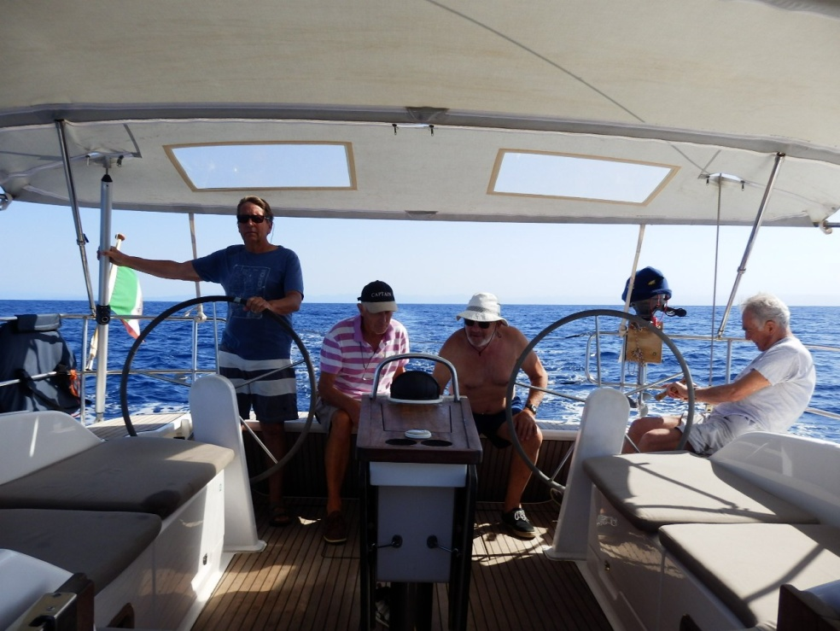

Day 3 Destination Stromboli

Leaving Panarea after breakfast we set sail for the island of Stromboli which possesses the only active volcano in the area and is so high at 3000 ft above sea level is visible for miles.The spectacular eruptive phenomena can be admired from the sea and at night the red glow from the lava flow on the north west coast is most impressive. We had another fine sail to Stromboli and got as close as we could but did not land there.

Strong winds were forecast from the north east over night so we decided to return to Panarea for a second night. The company letting the moorings also provided a water taxi service so we could go ashore for more provisions and a drink at the bars along the waterfront.

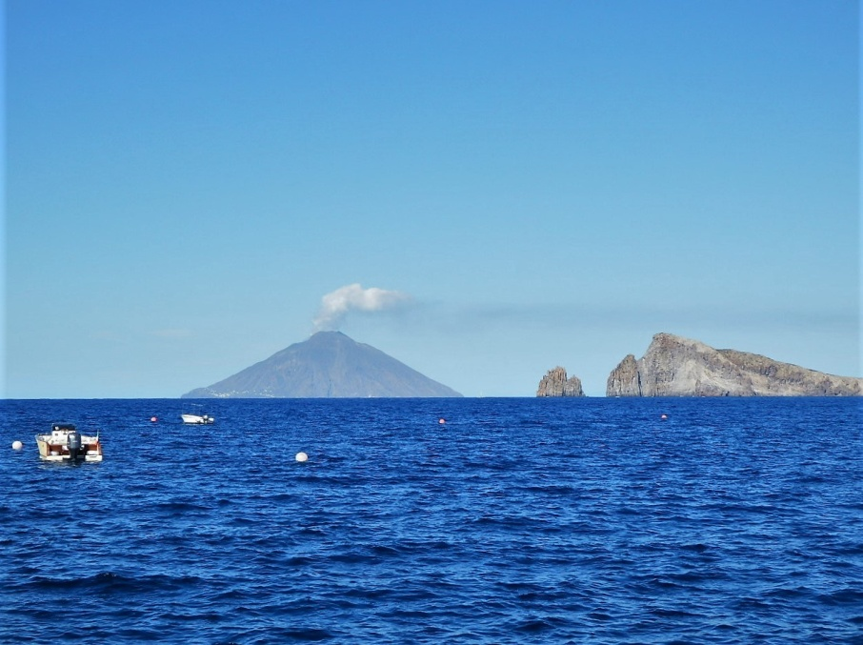
Day 4 Destination Lipari

After a rough night on the mooring and winds up to F7 - F8 we decided to run for cover to the next island. The seas were as rough as I have ever seen them with the wind whipping off the tops of the waves and making a very wet passage, so we were very grateful that the boat was equipped with a reliable and powerful 72 hp Volvo diesel which pushed us through the crests and troughs to the safety of Eol.Mare marina on the island of Lipari. Four people arrived to help us tie up to an outside pontoon as the strong winds made it difficult to manoeuvre inside. Lipari is the main and most populated island and its port is small and busy.

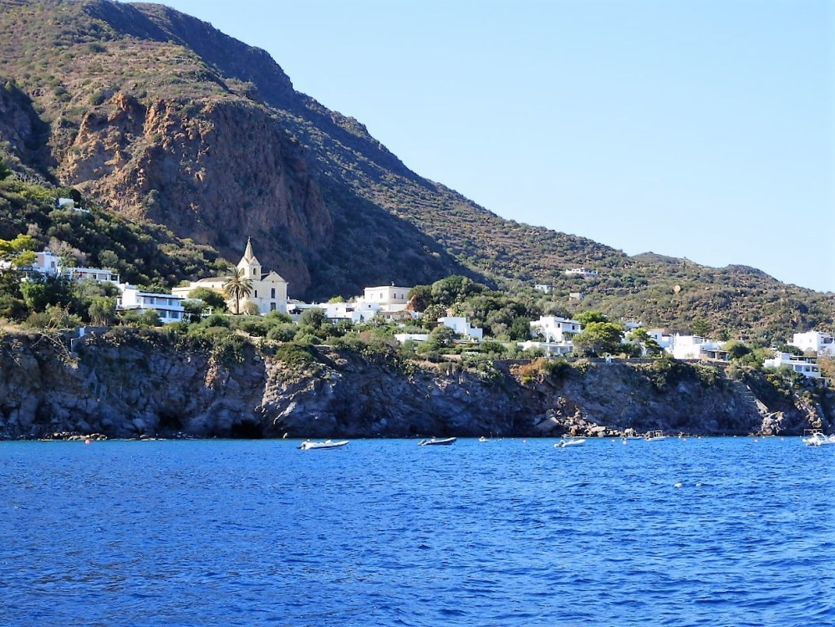

Day 5 Destination Vulcano

The day dawned bright with a nice breeze and we set off southwards to sail to Vulcano following the coast of Lipari with its high cliffs and dramatic landscapes then after a short while picking up the coast of Vulcano rugged and barren with lava eroded by the wind into strangely shaped volcanic outcrops and high cliffs.

It is probably the most popular of the Islands and attracts a lot of people on vacation during the season with many shops, bars and restaurants close to the marina and ferry terminal. The main attractions were the proximity of the volcano with the possibility of a walk up to the crater and hot therapeutic mud baths on the edge of town.

Our first impression on arriving was a strong smell of hydrogen sulphide in the atmosphere which wore off as we became acclimatised and a beach of small coloured pumice stones.

Day 6 Destination Portorosa Marina

We were required back to Portorosa Marina by 16.00 hrs so had a gentle sail back to Sicily where we dropped anchor in a sheltered bay to have lunch and a swim before heading back to the marina.

Day 7 Homeward bound

We vacated the yacht at 08.00 hrs leaving us the rest of the day to drive back to Palermo and head for the airport.

Ray Clayton

