Circe’s Cruise: The Netherlands Summer 2017
Having had a successful cruise in 2016 incorporating the South Coast, Isle of Wight and Boulogne. Thoughts moved on to 2017. I have cycled in Holland on many occasions but never sailed there. A quick internet search identified two pilot guides one was on revision seven the other on its second edition. I went for the second: Inland Waterways of the Netherlands by Louise Busby and David Broad.
Route 1 Zeeland a mast up route entered from the south all seemed fine as I could go to Ramsgate and then up the French and Belgium coasts making a couple of stops on route.
Ray Hutchins, ex work colleague, cycling, sailing, canoeing and general fiasco companion agreed to 10 days, so a loose plan was hatched we would take the boat to Holland and Ray's wife, Glynis, and my wife, Sarah, would join us there. Sarah’s Brother Ian would join me for the return journey.
It was agreed that we would meet the girls at Vlissingen, the start of our inland cruise and conveniently, located at the end of the railway line so easy access for crew changes.
Having taken the boat to Shotley the day before, a 6am start taking the flood South saw us heading for Ramsgate on the 7th July. As we had all day we took the slightly longer but deeper water route out to Long Sand and South via Kentish Knock. A route of some 49 miles saw us arriving in Ramsgate around 4pm.
A fellow boat owner took our lines and was quick to inform us that he had taken a detour due to engine trouble but that his two colleagues had gone on to Ostend and had both been fined 500 euro for having red diesel in their tanks. Fantastic news at the start of a holiday, they had also been told that the French and Dutch would fine them even more.
So having showered and eaten a chilli which we brought from home, it was a subdued skipper and crew making the climb up to The Royal Temple Yacht Club for the obligatory couple of pints. 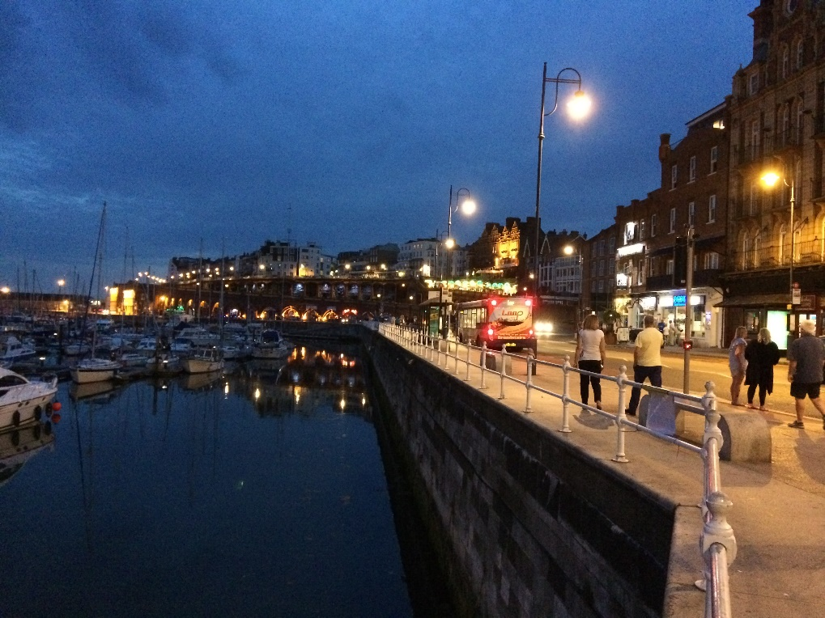
There was no way I was going to abandon the trip, so I decided to go Dunkirk and then onto Breskens Holland avoiding Belgium altogether (It is well documented about Belgium issuing fines but I wasn’t aware of the same in Holland). Ramsgate and Dover now supply white diesel.
8th July: After topping up on fuel we set sail, North around the Goodwin Sands, crossing the shipping separation zone via the Sandettie Light Vessel and onto Dunkirk 42 miles. On checking in to pay and get the gate and shower codes etc a tired looking young attendant said that because of Brexit he should photo copy our documents at which point Ray reminded him that we hadn’t left yet. Anyway, he didn’t insist, it was almost 7pm and the end of his shift. The facilities at the marina were very good, and included a restaurant but we decided to walk into town for the obligatory Moules and Frites.
9th July: A pleasant day motor sailing up the Belgian Coast when a couple or so miles of Ostend I stood up to do what a man needs to do and was surprised to see a dolphin swimming alongside almost touching the hull, it stayed for a few seconds before peeling off under the bow of the boat. We arrived Breskens mid-afternoon checked in and headed to the bar for a couple of pints, the TV was on where Froome was ahead in the Tour De France. The marina has a number of trade bikes for return trips to the local supermarket which we duly made use of. A total of 52 miles for the trip, that’s not the supermarket.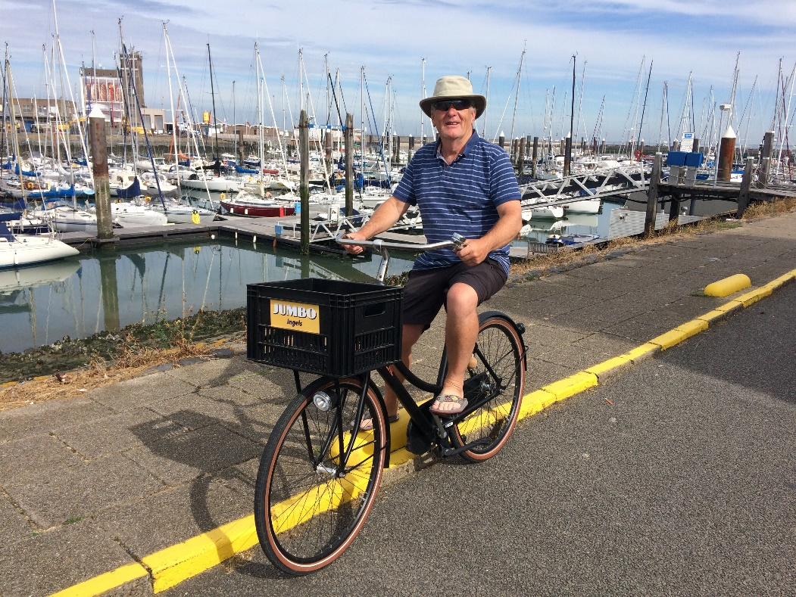
10th July: We hadn’t realised but there are two entrances at Vlissingen. It is only 2 miles across Westerschelde and we thought we were heading for the entrance to the canal system but fortunately found the town harbour Michael de Ruyterhaven instead. The entrance is busy with pilot boats coming and going but once inside you are surrounded by the old town with cafés, bars shops and restaurants. We had a couple of nights here enjoyed the town, found the railway station so we could meet the ladies the following day. 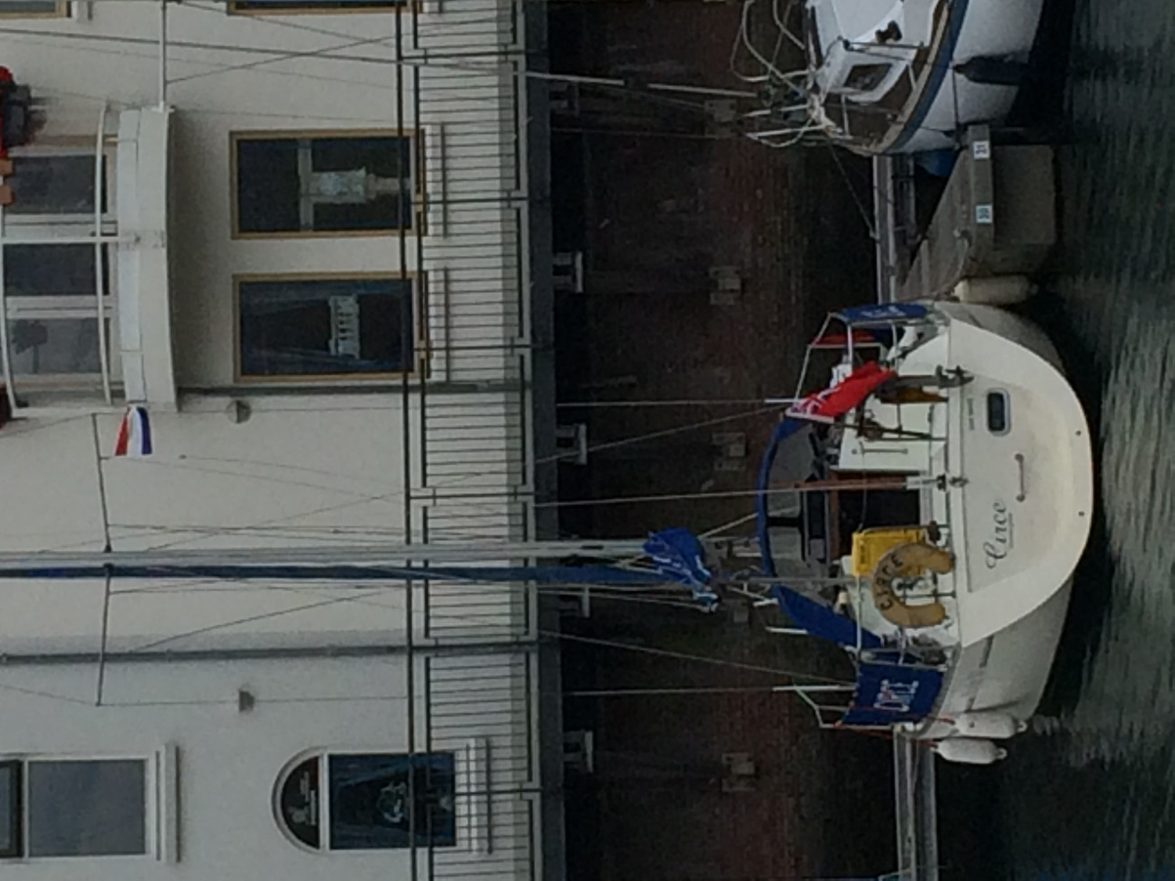
12th July: A fresh breeze found us motoring the 1 mile or so up the Westerschelde, locking in to the harbour adjacent to the ferry terminal. Travelling the short distance through the harbour we moored up for lunch whilst waiting for the second lock and road bridge to open for the ‘Kanaal door Walcheren. The bridge opens every couple of hours the times are clearly displayed on an illuminated sign on the bridge. Once in the canal you tend to travel in convoys of 5 or 6 boats with bridges/locks operating ahead with minimal delay. Two stops on this canal firstly Middleburg a very attractive town with a really nice Clubhouse. Mooring in boxes which is basically between posts. So typically nose to the quay with stern lines attached to posts either side of the transom. A meal in the sailing club followed by a walk around town and we found ourselves in a bar with a great little jazz/blues band playing to an attentive audience. 7 miles for trip.
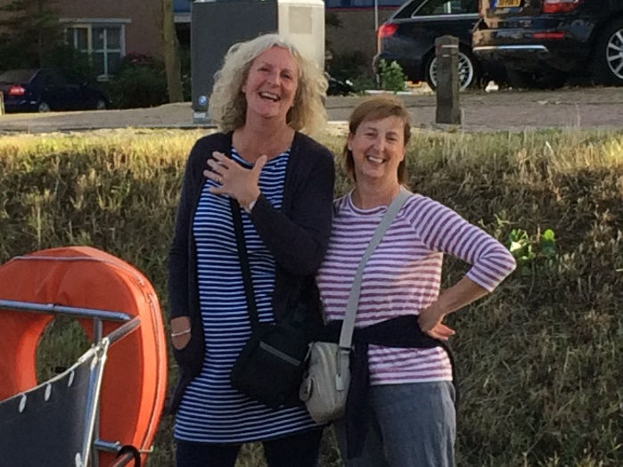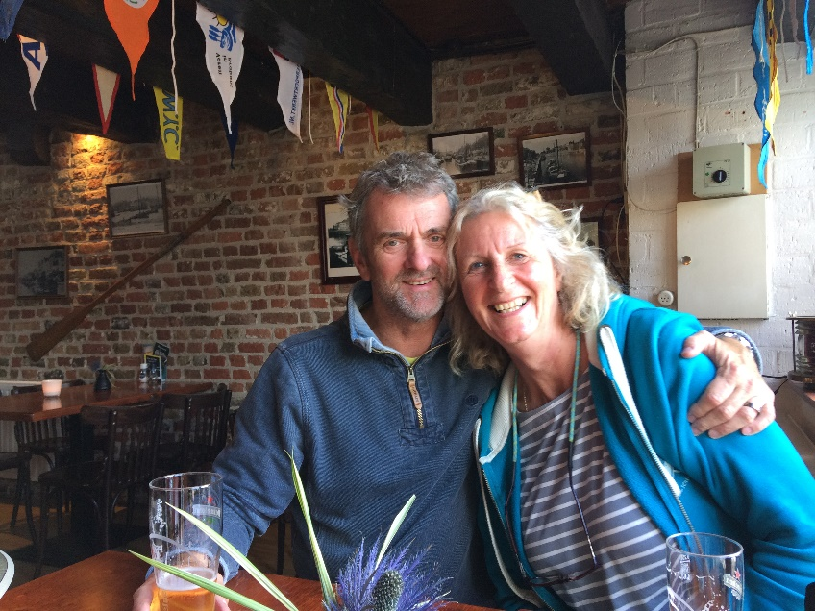
13th July: After a morning enjoying the market and general ambience of Middleburg we took the short trip up the canal to Veere a quaint and very touristy village a bit like Dedham on steroids. No food shops here other than a bakers but basic supplies could be purchased from the sailing club. 5 miles for trip.
14th July: Leaving Veere and the canal we locked out and into the Oosterschelde which enabled Glynis to have her first sail on open water. Entering the Havenkanaal via the sea lock its then on up to Goes. Mooring in the central basin of Goes requires passing through two bridges which are opened on the hour by a harbour master who cycles between them. Welcome: thank you, where are you from answer Harwich: yes but where? Manningtree, on the River Stour, yes. I am an honouree member of Pin Mill Sailing Club said the harbour master. I spent three days in Goes, Ray and Glynis caught the train to the ferry on the 15th Sarah left on the 16th and her brother Ian joined me on t17th.
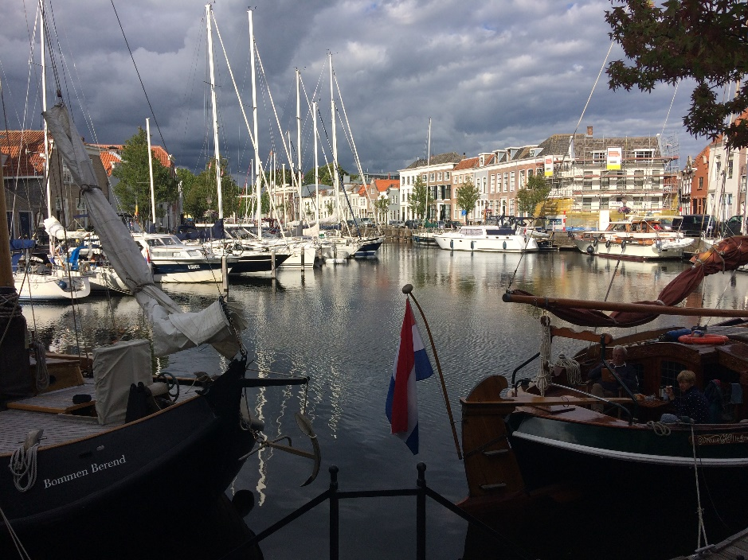

Ian arrived around 4pm and we took the 5pm bridge opening and back down the Havenkannal to the sea lock for the Oosterschelde, with wind on the nose and the day drawing to a close we motored across the Oosterschelde entering Zierikzee around 8.00 pm. This was the busiest port on the trip with literally hundreds of boats moored up, we ended up mooring 3 deep, many were moored deeper. So a shower, food on board and a brief walk to a bar for a beer. 8.5 miles
18th July: Unfortunately the inner boat wanted to leave at 10am so I decided to leave at that time but in hindsight we should have stayed a bit longer as the town seemed to be very pleasant. So a glorious morning saw us heading for Roompot sluice and out into the north sea. A beautiful sail down the coast and a return visit to Breskens, topped up with fuel, couple of beers and a cycle to the supermarket. 27 miles.
19th July: Early start, hazy morning which soon warmed to a glorious morning saw us heading back to Dunkirk. With around 5 miles to go the tide turned against us and the wind strengthened and it became fairly rough, we were caught on the hop without wet gear on. So after a heavy slog skipper and crew fairly wet by now safely entered the harbour at Dunkirk. Moule and Frite again.
20th July: with the wind blowing a force 6 we had a day exploring Dunkirk this was just before the release of the film Dunkirk and the town seemed to have Dunkirk fever. Evidence of film sets, posters memorabilia and even a museum and street dedicated to operation Dynamo.
21th July returned Ramsgate.
22nd: Returned Shotley this time via Fisherman’s Gat, 6.5hours for the trip.
On entering the harbour we were greeted by Katla and crew heading back to its mooring at Wrabness. Locking in to Shotley Marina I called Stuart Howells and Will Langton who would be returning to the marina after a combined clubs they took us back to Manningtree, dropping Ian at the station for his train back to Beccles.
I haven’t hatched a plan for 2018 yet.

