A VISIT TO BRUGES
Jerry Garner

Iroquois Catamaran “Makeda”
Skipper: Jerry Garner
Mate: Margaret Garner

Introduction
We had been thinking of doing a North Sea crossing in Makeda and decided we had better do it before Brexit. Not that British yachts will be prohibited after that but I could foresee a lot of hassle with neither yachtsmen nor officials quite knowing what the rules are in the first year or two. We had done a North Sea crossing before but that was in 1976 in a chartered yacht with 3 small children. There were no windfarms in those days and only one designated shipping lane.
We decided to aim for Blankenberge in Belgium. We chose Blankenberge because it is only 15 minutes by train from there to Bruges. Bruges is a lovely old city with lots of interesting buildings, we had been there twice before but our last visit was nearly 20 years ago.
The pilotage information suggested one should enter and leave Blankenberge harbour within 3 hours of high water, because the entrance channel tends to silt up. Unfortunately that would mean we could not have the tide with us on the route from the West Hinder past Ostend to Blankenberge which is about 4 miles south-west of Zeebrugge. (When in Blankenberge we saw deep keeled yachts going in and out at all states of the tide, perhaps because they normally dredge the entrance each June.)
Makeda
An Iroquois Mk II catamaran. Built at Brightlingsea in 1969. 30ft long, nearly 14ft beam, twin centreboards. Engine a 9.9hp outboard (Hence no problems with red diesel in Belgium!).

Monday 25 June 2018 HW Mistley 1107
We left our mooring at Manningtree at 1100 and beat down river against a rather variable easterly breeze force 2-3. By 1235 we were passing Holbrook posts. The wind had now increased to ESE4+ and we put a reef in when approaching Parkeston. We cleared Harwich breakwater at 1315. It was a hard beat but the sea was smoother once we were clear of Harwich.
We held our port tack into Pennyhole Bay and tacked round the racing buoy there. By 1440 we were between Stone Banks and Medusa. We had to take another tack south to keep clear of the Cork Sand. At 1540 the reef was shaken out and “Birdie” our autopilot was just coping with a close-hauled course towards Long Sand Head. The wind was now SE2 and at 1633 the NE Gunfleet buoy was abeam to starboard. The Dynamo buoy was abeam to starboard at 1720, the wind was slowly tending to back.
At 1815 we tacked, just north of Sunk W2 buoy, and were now tracking 201º down the east side of Long Sand. An hour later we had to tack to avoid a trawler coming NE from the London Array windfarm but we would soon have been due to tack anyway. We were now heading to cross the Sunk traffic separation scheme at right angles.
We added the engine at 1945 to maintain speed while crossing the shipping lane and I went below for a short snooze, leaving Margaret in charge. By 2020 we were across the shipping lane, turned the engine off and tacked again.
I was on watch at 2325. We were tracking 130º at 6 knots. It was a beautiful starry night, the “saucepan” (The Plough!) was over the stern and the full moon ahead, it was not really dark.

Tuesday 26 June HW Dover 1108 BST
At 0100 “Birdie” lost the plot when the wind suddenly backed NE and went light for a while. After a rapid return to manual steering and adjustment of sheets we got going again and Birdie returned to duty. About 0200 the wind freshened and we were soon charging along at 6 knots plus. We later rolled up a bit of jib to keep things under control. For some reason the GPS gave us a completely wrong direction for the West Hinder so we skipped that one and headed for the waypoint beyond it. The West Hinder buoy was to port at 0418. Crossing the shipping lane after West Hinder we had to take evasive action for a RoRo coming up from the south. It was now 0520 and, due to the ENE breeze, our track of 130º was taking us well south of the easterly course for Blankenberge. We passed south of the Oostdyck ship anchorage and later crossed a shallow patch of about 5m where there was quite a bit of broken water; somewhere to avoid in a blow.
We tacked off Ostend at 0910, to head north. Progress was still slow due to the adverse tide. After 1100, as the tide turned, we made better progress and eventually headed slightly south of east, just south of the shipping lane for Zeebrugge. The wind had now increased to force 4-5 and we decided to put one reef in. Half a mile before the entrance to Blankenberge we rounded up, lowered sail and motored in between the two piers. At the end of the narrow entrance channel we turned left into the old fishing harbour and moored to the long visitor pontoon on the south side at 1400. This is the yacht club marina. The other harbour is a large marina that seems to be mainly local yachts. The marina charged us 40 euros for 2 nights, cheaper than we expected but you have to put coin in the slot for showers and electricity and even for waste disposal.
Wednesday 27 June
We slept well. Had showers followed by a late breakfast, then changed into smarter clothes and walked to the station. Unfortunately we had just missed the one train per hour, which left as we were buying our tickets. To fill in time we walked to the sea –front. From seaward this looks awful; a solid mass of 5 storey buildings. The beach and promenade is really just like Clacton or Southend. This is one of the most popular seaside resorts in Belgium.
We stopped for a coffee on the way back to the station then got the 1054 (Belgian time) train to Bruges. This was a long distance train with double decker carriages. Bruges was just the first stop on a journey across Belgium via Brussels.
From the station at Bruges we walked into the old town and visited various churches etc that we had not seen on our previous visits. Bruges was much more touristy than we remembered but many of the places we went to see were not on the main tourist itinerary so were not over crowded.
We got the 1852 train back from Bruges (it was 8 minutes late). Having walked back to the marina we had a nice ham salad meal aboard (salad chosen to prevent scurvy on the voyage home). Afterwards we connected the electricity to top up the batteries and looked up the chart and tide details for the next day.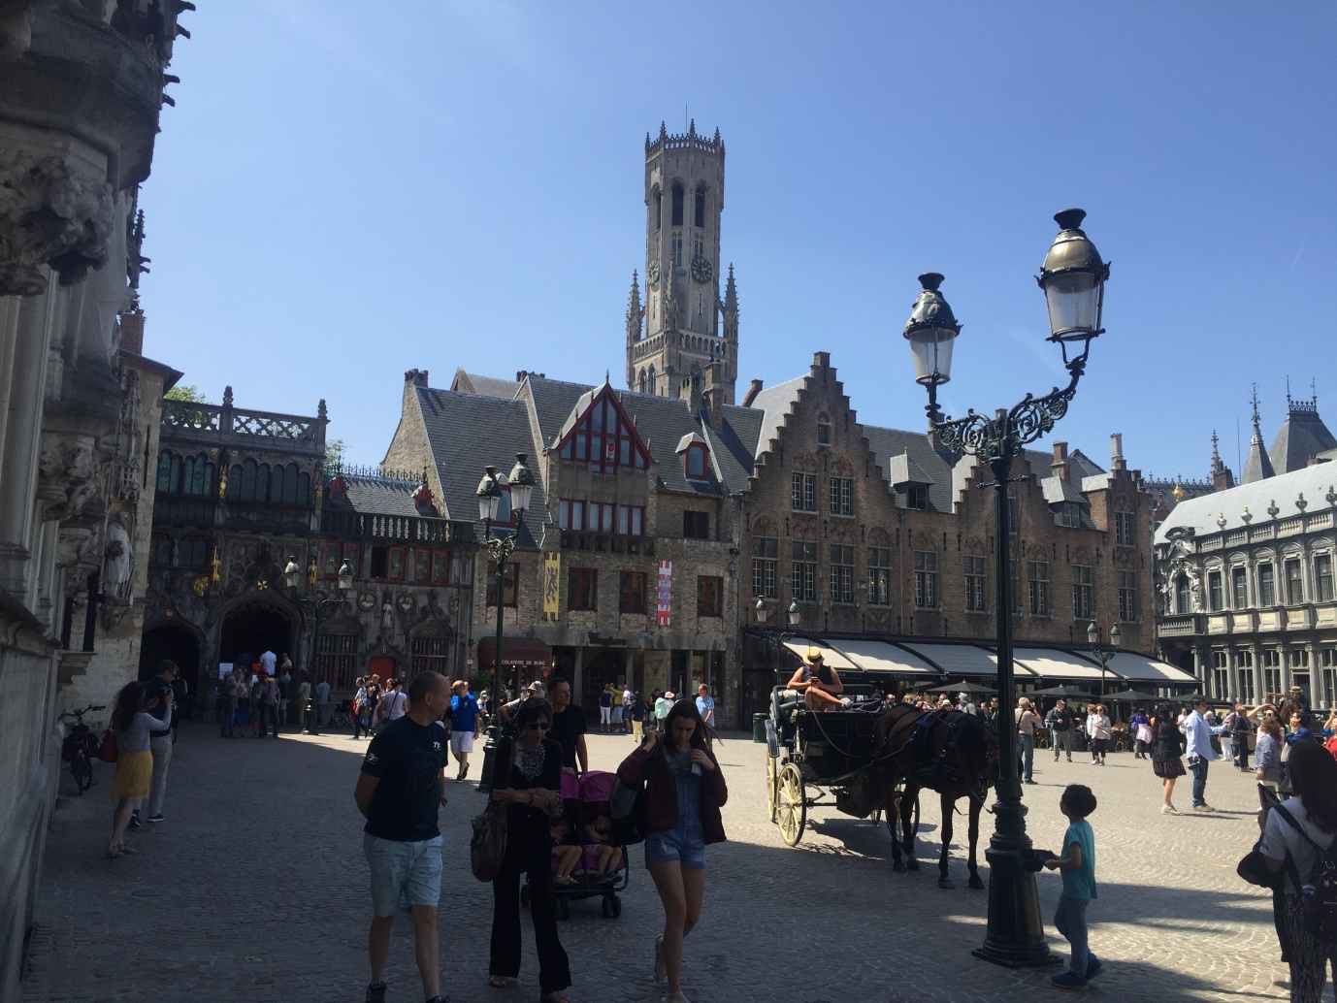
Bruges, the main square and the famous belfry
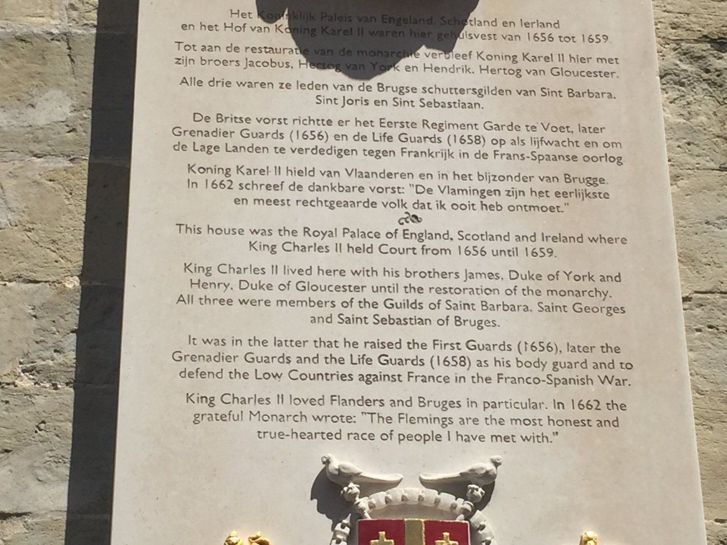
The origin of our Grenadier Guards and Life Guards
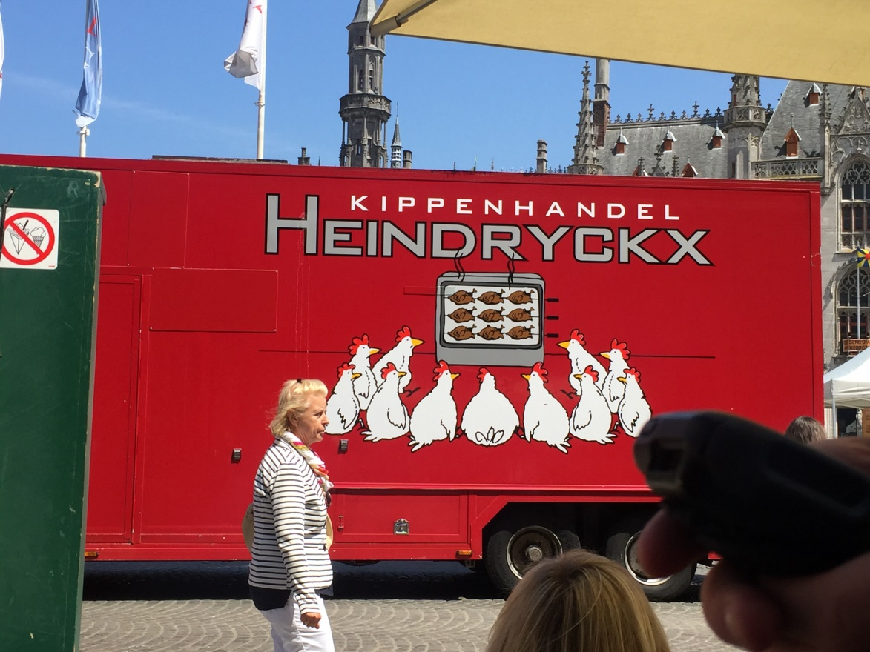
Bruges: Seen in the market, I don't think the illustration on this poultry firm's lorry would be acceptable in Britain!
Thursday 28 June HW Dover 1938BST
Got up to a sunny morning and had a late breakfast. The shipping forecast for sea area Thames was NE4/5 increasing 6 at times, slight/moderate seas, Fair, Moderate-Good visibility. At 1015 I was checking the course and waypoints and preparing for sea. Margaret was snoozing in the sun.
We left Blankenberge under power at 1300. The wind was NE 4-5. We hoisted main with one reef and part rolled jib. By 1320 we were outside the Blankenberge buoys in a steep sea with white horses. At the AW1 buoy about 4 miles offshore we bore off on our course for West Hinder.
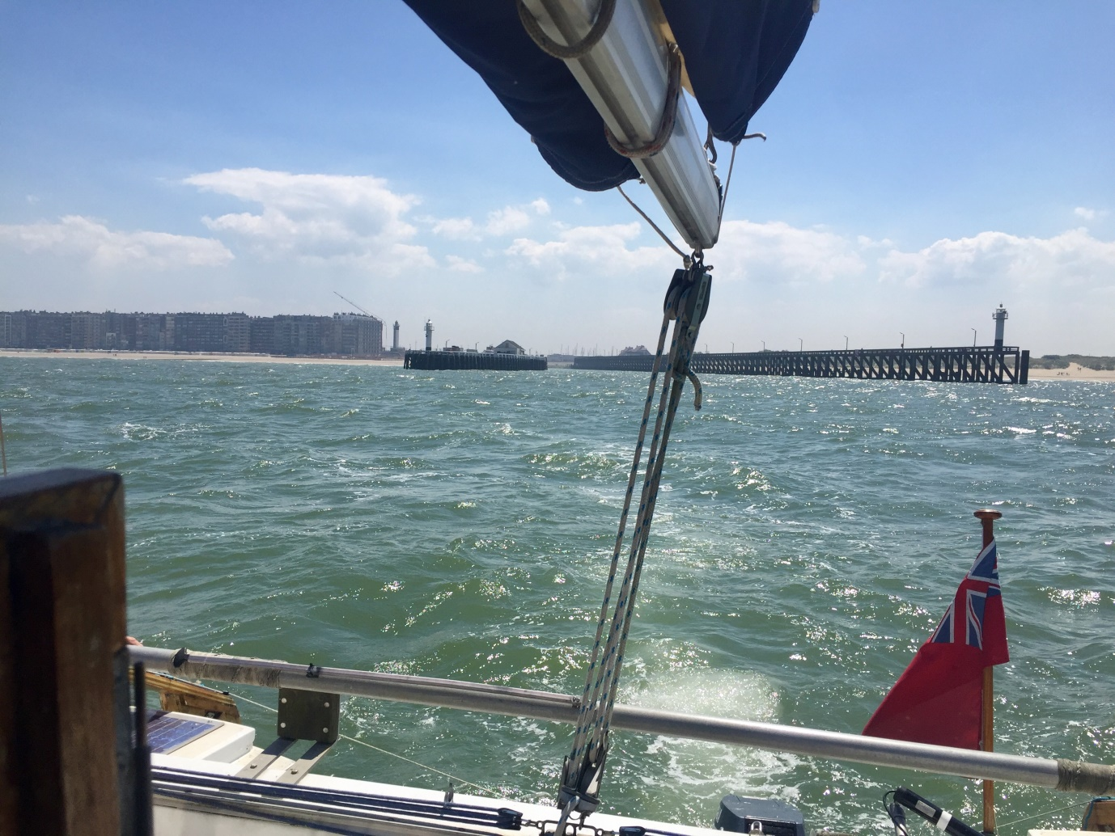
Blankenberge and its harbour astern

We now switched our clocks to BST and at 1453 were passing the MBN buoy about 5 miles off Ostend. Two hours later the wind increased to force 5-6 and we decided to put the second reef in.
Although we have single-line reefing operated from the cockpit I had to go forward to the mast to release the line that holds the sail slides in the track. As I came back off the coachroof, feeling for a foothold in the cockpit, I put my foot on the Autohelm’s control box which fits on a plastic bracket on the forward side of the cockpit. The bracket broke and Birdie became completely disorientated! A quick return to manual steering got us under control. Once we were reefed Margaret did manage to strap the box back in position but we were close-hauled for the rest of the trip so Birdie would not have coped as the sea was quite rough.
The West Hinder buoy WH S was reached at 1700 and from there we were hard on the wind, heading towards Long Sand and Harwich.
It was getting dark about 2130. The sea was very rough and confused, with the wind force 6 at times. There was a lot of spray and occasional wave tops hit the front windows but Makeda does not usually ship green water. In fact the boat was a lot cleaner when we got back than when we left! The closest we could point in these conditions was taking us towards the middle of Long Sand. Although not crossing the shipping lane exactly at right angles, we felt it was near enough to ignore the dog-leg plotted on the chart.
Friday 29 June HW Harwich 1325
We passed just to the north of Kentish Knock sands and, as we reached Long Sand at 0025, tacked up the east side until we could pass Long Sand Head buoy at 0300. We were on starboard tack, heading for Medusa when, just before it got light, we met a yacht heading for us on port tack. It was steering a rather wandering course and I nearly had to take evasive action before it passed us less than 20 yards to port.
At 0500 we tacked at the Medusa buoy and beat towards Stone Banks and Harwich breakwater, where we put the engine on. We rounded Harwich Shelf at 0715 and called up Shotley marina, thinking of having a nice sleep as we were both rather knackered. Unfortunately they told us the lock gates would not be opening until 1200, which was no good for us so we headed up river. We anchored west of Erwarton Post at 0755 and collapsed into bed, having removed the Belgian courtesy ensign first!
We slept in until 1230 then had coffee, a wash and brunch. We spent the afternoon drying out and resting.
Saturday 30 June HW Mistley 1423
Up at 0800. Breakfast, various boat maintenance jobs plus sunbathing and reading books. The wind was easterly about force 4.
At 1220 we left Erwarton and sailed up river with one reef in the main. Among the many yachts out for a Saturday sail, we passed our son Simon sailing single-handed in Bushwakka. Running before this force 4-5 breeze we were doing over 6 knots and passed Stutton Post at 1253. We were on our mooring and ready to go ashore at 1345.

