Lionheart 2021 - A Gentle Paddle (Halfway) Around the Coast of GB
I was walking along the platform about to board the Paddington – Penzance Express wondering what on earth the next few weeks would bring and how I had arrived in this situation. When Maria suggested doing a Leg of the Lionheart Round Britain Row I scoffed at such a ridiculous idea and then a few days later I was signed up for three Legs from Penzance to Fraserburgh.
Fortunately, I would not be entirely alone with other SSC members also signing up: Maria and Shirley for Leg 3; Sarah, Lorena and Sam for Leg 4 and Caroline for Leg 6. We had managed to get in some longer stamina training rows in the gigs in the run up to the event attempting to get from Manningtree to Titchmarsh Marina and back on three separate occasions but never quite making it before the tide turned. We also attended a training weekend in May to meet our fellow rowers and understand what was expected of us. There was only one element of the row missing at this point – our boat Roxy which was en route from the Caribbean after an Atlantic crossing. Perhaps if we had spotted the living conditions we might have been a tad less naïve about life on board an ocean rowing boat.
The first leg from Burnham on Crouch to Penzance had been completed in hot sun with mostly a gentle breeze and I would soon be meeting my new shipmates for a beer and last supper before embarking.
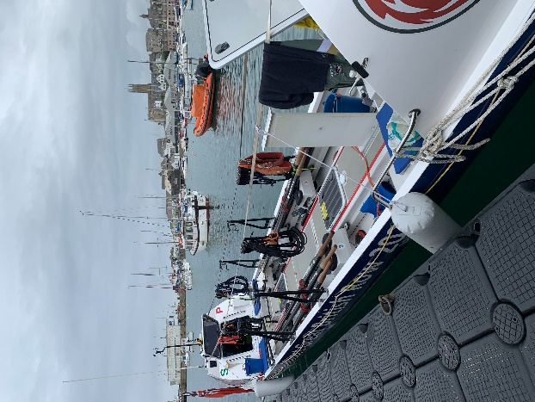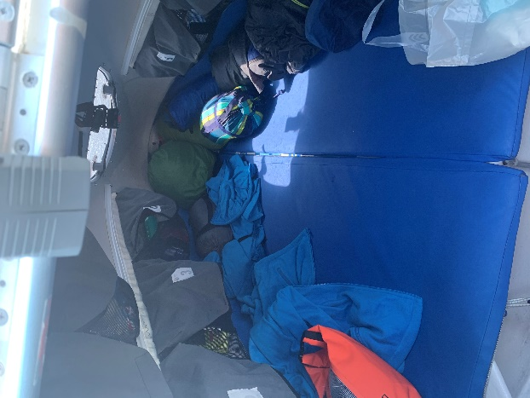
Roxy ready and waiting Plenty of room inside for three

The next morning after the ‘full English’ for some carbo-loading I lugged my kit down to the quayside, climbed onboard and met the rest of the team. Roxy has a crew of 12 but only accommodation for six. So, at any time half the crew would be rowing or at least on deck and the other half out of the way in either the forward or aft pods. We were split into four watches of three and I was sharing the fore ‘cabin’ with Mark and Ali, a couple of really nice guys with plenty of experience who were doing the whole Round Britain circuit.
I use the term cabin loosely. On entering through the hatch there was a triangular area starting at about the width of a small double bed and narrowing towards the bow. There was a step and standing position enough for one person to ease in and out of the cabin at a time. A small stowage area for kit and a slide-in coffin for one of the lucky three for sleeping. Nestled on a shelf was a portable Jetboil and along the side of the cabin were some pockets to tuck necessary items plus daily food allowance.
I resolved the need to be absolutely on top of personal admin over the weeks ahead, looking after myself and my kit. Thankfully the other two were of the same approach although our opposite watch who we alternated with proved to be less so and we would often return to a messy pit.
Leg 1
Penzance – St Ives 28 NM; St Ives – Fishguard 123 NM; Stranraer - Glenarm 37 NM
Total 188 NM
We agreed we would leave Penzance mid-afternoon and we set off for some last minute purchases and a relaxing lunch. We eased out of Penzance Harbour about 2.30pm in bright sun and for a very short while a following light breeze. Little did I realise that this was the last favourable wind I would experience until my last day.
Our plan was to round Lands End, head up the Cornish coast for a while and then straight across the Bristol Channel towards Milford Haven, round St Davids Head and then follow the Welsh coast and then the Irish coast up to Belfast. A simple enough plan but the execution was rather more difficult.
Penzance Harbour was soon receding as I got the feel of rowing this boat. With six of us we were managing around 3 knots with a bit of help from the wind and tide about slack. It is a sliding seat, sweep oar boat, so just one blade to contend with. But with any sort of waves and with the movement of the boat every stroke must be carefully placed to avoid going too deep in a wave or missing completely in a trough.
As a fairly experienced oarsman I felt I could settle into this quite happily although I was apprehensive whether my body would cope with a routine of three hours rowing and three hours off for days at a time. I was also one of the newbies to the crew so wanted to watch and learn as we went. However, after about 20 minutes of rowing I had to ask them to drop the rate as they were all slamming up the slide at about 30 strokes per minute whereas I would have been setting a rate of about 20/22. So much for keeping quiet. This became a long-term battle over the coming days to prove that it was more efficient and effective to slow it down. I realised that even those who had crossed the Atlantic had little rowing coaching and some of the crew had no rowing experience and were struggling to cope as best they could. Selection for this event was strictly ability to pay not capability to row.
As the afternoon wore on we passed Mousehole and made our way along the coast, I pointed out Porthcurno the landing point for many undersea telecoms cables and we rounded Lands End during the evening. At this point the wind shifted to head us and the seas started to slam into the bows. We were on the 9pm to midnight watch and it was full waterproofs as waves slopped over the side of Roxy. The forecast had taken a turn for the worse with strong northerly winds forecast. Initially we still felt that we could head up the north Cornish coast but as the night wore on it became certain we would need to seek shelter in St Ives.
We handed over to the other watch at midnight and took shelter in the cabin they had just vacated. Making a hot drink on the Jetboil as we were being thrown around became a challenge to avoid a serious scalding and for the first and only time on the voyage I felt a little queasy. Of course, as the new crew member I was allocated the coffin so slid myself down and into the tight confines for a sleepless hour or so before it was time to get up and out and ready for the next watch.
After a fight to get waterproofs back on we were out on deck to find we were just arriving in St Ives harbour and shelter. It also meant that the other watch could snuggle down for some sleep whilst we had to sit on deck on ‘anchor watch’ which was a euphemism for there is nowhere else to go. Bang on time the rain started to cascade and the wind by then was a full gale. A perfect environment to get to know your colleagues as we turned our backs on the wind and rain and chatted the night away. Slowly the cold seeped into us and by 4.30 we were jumping around to warm up with a spontaneous performance of YMCA to the empty streets of St Ives. By 6am the tide had gone out so we could walk ashore on the sandy bottom and explore a very closed St Ives eventually finding a café for some hot drinks and breakfast.
Over the next two days we got to know St Ives quite well as we waited for the weather to improve. We had found some accommodation so could dry our clothing and sleep comfortably. By Wednesday morning the forecast was more positive but the wind was still northerly and quite brisk as we left the shelter of the harbour watched by holiday makers on the pierhead observing our slow progress as we headed straight across the Bristol Channel aiming for the Welsh Coast.
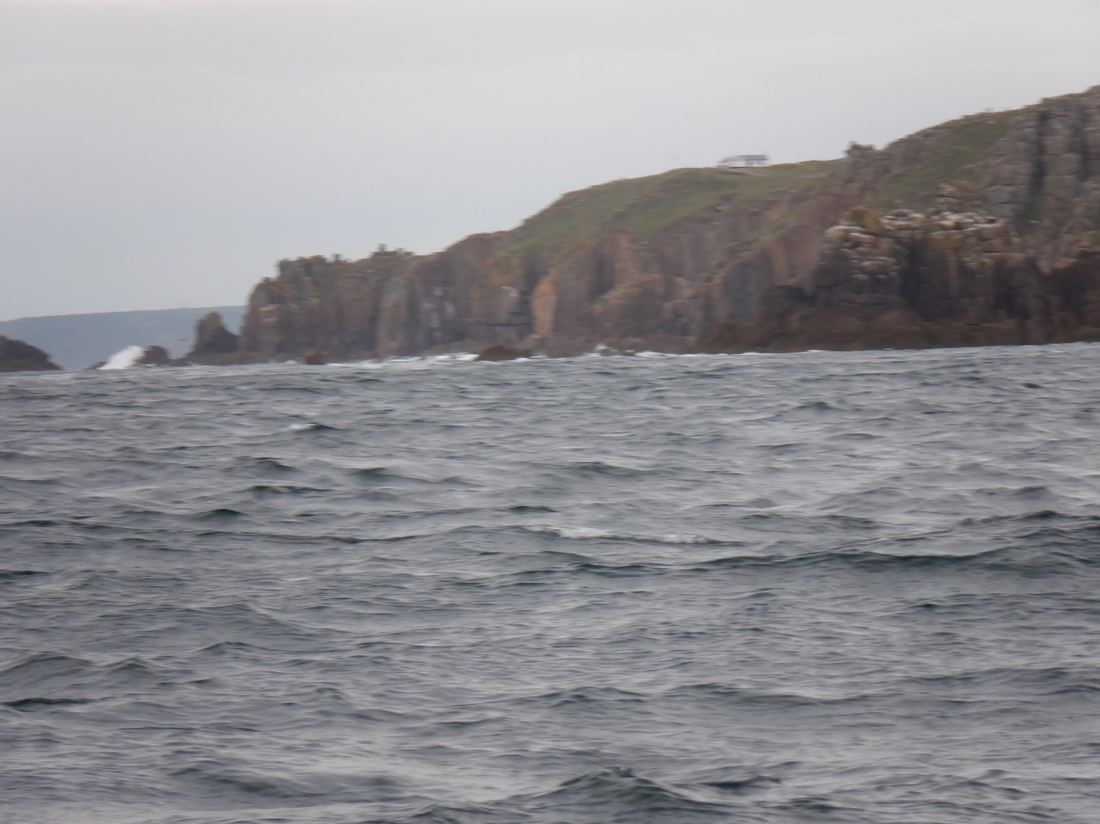
Leaving St Ives and the weather has actually improved

There were still white tops on the waves and a dead headwind and even after three hours rowing the coast seemed quite reluctant to let us escape. The ocean boat design is aimed to make use of the favourable trade winds from the Canaries to the Caribbean so a very rounded bow and stern. With wind behind the rowing is easy; wind ahead is sheer effort to gain each metre of progress. Once out of sight of land it is difficult to judge progress apart from the readout on the aft cabin which was showing speed over the ground and wind direction and strength. Neither were encouraging. More dispiriting was the occasional buoy which seemed static and in sight for literally hours.
Each three hours of rowing seems endless especially the last thirty minutes. The only break was to visit the loo. When I say loo I mean a plastic bucket positioned in front of the hatch window of the forward cabin. Removing outer layers, balancing with the boat rocking and pitching and focusing on the matter in hand became an art. Even more demanding for the ladies and for number two’s which I will not detail. There was a modesty cloth that could be fixed over the cabin hatch to shield those inside but after a few visits that was redundant if the inhabitants were sleeping or simply advised to look elsewhere.
Once off duty the routine was to unhook the lifeline, remove wet weather gear and wet shoes and then clamber into the cabin. First one in would fill the Jetboil and get the water on to boil, whilst the other two crammed into the limited space and selected their dish of the day.
The dishes were dried food in sachets; breakfast porridge or muesli or the inedible scrambled egg with cheese, main meal included a meat or bean stew or a chicken korma and pudding rice or a chocolate mix. Just add boiling water and wait five minutes and it was ready to shovel into hungry mouths. When I first joined the boat I was amazed at Mark and Ali’s farting prowess but after a couple of days I was one of the orchestra as the dried food had its digestive effect.
After eating we would settle down for rest and hopefully sleep although with the movement of the boat and the slapping of waves on the bow it was difficult. As we crossed the Bristol Channel the pattern of row until exhausted after three hours then eat and rest became routine. Whilst we rowed with the aft two watches the only times we saw our opposite numbers from our cabin Arya, Neil and Rick was as they relieved us at our rowing seats and then when we returned ready for some more.
Over the next couple of days we could see them looking more tired and worn with every session. No doubt they thought the same of us.
Apart from the repetition of rowing about 3,500 strokes every three hours there were some highlights with our watches coinciding with dusk and dawn and a full moon crossing the night sky for the next couple of days too.
Eventually with improving weather the coast of Wales came within sight and we were heading for the gap between the mainland and Skomer Island. Sea birds aplenty and some warm sun as we approached. With help from the tide we were making good progress now and when we hit the tide race between St Davids Head and Ramsay Island we managed the fastest speed Roxy had so far managed at 10.8 knots over the ground.
Our joy was though short-lived as the weather forecast gave us strong northerly winds and rain for the next couple of days. It was clear we would not make it up to Belfast by Sunday to swap some crew members and start Leg 3.
Reluctantly the decision was made to put into Fishguard that night and arrange for a trailer to take us up to Stranraer in Scotland and then hop across to Northern Ireland. We hastily got onto our phones and managed to book a B&B so we could have a comfortable and dry bed for the night. No sooner done than the weather deteriorated, and we got into harbour as wind and rain strengthened. The walk to our B&B took forever as we skirted the docks and walked out of town, and we arrived after 11pm wet and cold but delighted that a pizza takeaway would deliver this late.
Next day after breakfast we found that Charlie our Skipper and his team had worked wonders and we boarded a minibus heading across Wales and up the M6 and M74 for another overnight at Stranraer. The boat followed on a trailer to the surprise of those following its position online with its sudden burst of speed. Rick who had reached his limit off the coast of Wales decided not to join us.
The next day we set off heading north up Loch Ryan into our familiar head wind which again headed us as we turned west across the Irish Sea towards the coast of Northern Ireland and the small village of Glenarm. An uncomfortable, tiring and chilly night but we were delighted when we arrived to be greeted by our new companions including Maria and Shirley. I had been promoted to the role of watch leader and had them both under my wing for the next week.

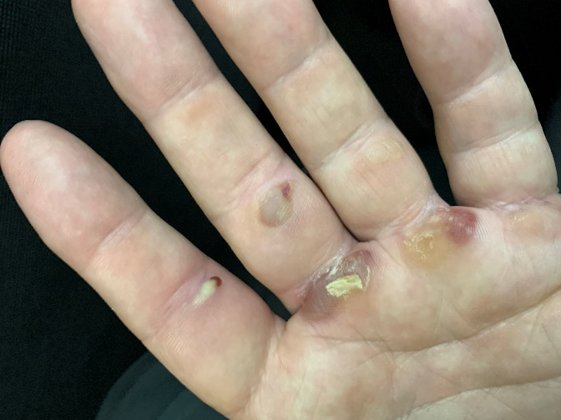
Ouch week one
Leg 2
Glenarm – Port Ellen 45 NM; Port Ellen – Oban 59 NM; Oban – Mallaig 83 NM
Total 187 NM
Another night in a hotel and off the next day, one day later than planned. The new crew members could not understand why we were late and why we were not eager to leave immediately. They were to fully comprehend not 24 hours later after a tough and rough row back across the Irish Sea, along the Mull of Kintyre and across to Port Ellen on Jura. It was a bit of a shock for the new crew members as they became accustomed to the routine of the rowing and off watch system whilst dealing with rough seas and some initial sea sickness. But everyone stuck to it and soon we were tucking into a breakfast in a local hotel. As the general view was that we would leave Jura around mid afternoon Maria and I managed to do a deal with a B&B owner for a room. Deep asleep I was woken at 11.45 to say there was a change of plan and we were to leave at 12 noon. Within 15 minutes we were back on board having spent £50 for 2.5 hours sleep – worth every penny.
For the rest of the day, we continued to row north-east along the coast of Jura and into the night past Islay with fog closing in. This far north the sky does not fully darken in late June and colours start to reveal themselves around 3am. The head wind was now a light breeze and we were making good progress as we heard the roar of the Corryvrecken whirlpool between the islands of Jura and Scarba. This was where George Orwell nearly drowned around the time he was writing 1984.
We needed to make a tide gate to carry the current or face 6 hours flogging against the flow or at anchor and we made it with minutes to spare and continued onto Oban, where again after frantic research and calls, an apartment was booked. We checked in then wandered along the sea front looking much like the other holidaymakers rather than the hardened mariners we felt we had become.
It was now Wednesday and despite leaving a day late we were ahead of schedule for our Leg 3 destination of Mallaig so it was agreed that we would row around the outside of Mull and then take in Muck and Rum and perhaps the coast of Skye aiming to arrive on Saturday.
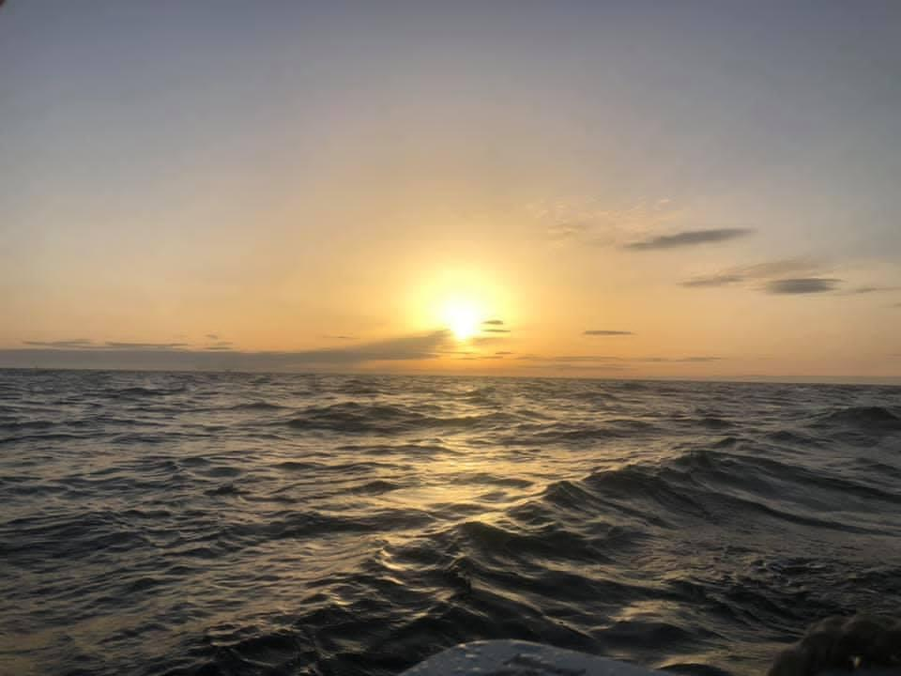
Sunrise

So, Thursday morning at 11.00 am we set off for our final part of Leg 3 in bright sun and almost calm conditions. We headed south-west into what soon became a sailors nightmare, a strong breeze with thick fog. Even with satnav we decided it was not a combination we wanted to test so we turned about to take the alternative route of the Sound of Mull between Mull and the mainland with of course a head wind and tide against us. We passed Lismore Lighthouse and went off watch for three hours returning to find it was still very much in sight.
Further along the sound one of my concerns of ocean rowing in coastal waters was realised. With six of the crew rowing and the others sleeping this leaves no one spare to keep a lookout. Yes, we did have AIS and individuals were making the trip to the bows to use the bucket and one of the rowers was following our course on his ipad; but we were probably not meeting the spirit and intent of the Collision Regulations of keeping a good lookout. We were making good progress with the tide when one crew member having been to the bucket wandered back to say there was a buoy ahead. ‘How far would that be’? ‘Oh about 100m’ A quick look made it more like 20m for what was speedily growing into a huge navigation buoy. A quick yell of ‘hold water’ and some furious backing down meant we missed it by inches and avoided what might have been terminal damage or worse. It turns out the buoy was obscured on the i-pad but it’s such simple errors that can result in a disaster at sea without a lookout.
The evening wore onto night and we missed sighting Tobermory where we had hoped to land in daylight. We continued with fog closing in and in the early morning heard but did not see Ardnamurchan lighthouse. Eventually we passed Muck and made our way around Rum which showed evidence of a history of farming and cultivation with wild sheep and goats on the shore but seemed almost deserted. Across the water we could see the Isle of Skye and the Cuillin Mountains where I had attempted the Cuillin Ridge looking down across to our current position back in my teens. My younger self would have been quite impressed that I was still doing it all these years later.
We rounded Rum and pulled into a beautiful inlet off Kinloch picking up a mooring buoy where we sat in the sun resting, snoozing, (some) swimming and (all) eating as the sun lowered in the sky. Here the sun hardly set with a faint glow over the north horizon all night. We headed off to the Skye coast which we followed and then across to Mallaig arriving around 4.30 am. Again, we had the ‘anchor watch’ which was spent lying on the pontoon cocooned in sleeping bags looking rather like a row of colourful seals although my snoring was probably louder than their grunts would have been.
After breakfast the whole crew apart from the Rannoch team were either leaving or had a week off. Maria and I headed off with Shirley and John for the night on Skye. They were staying in their caravan which John had towed up from Suffolk and we were off to the Harris and Lewis for a week in the very quiet and quite beautiful Outer Hebrides. After a night on a campsite in the north east of the island John kindly dropped us at the ferry at Uig the next morning.
The following Friday Maria travelled home via coach and train from Inverness and I rejoined Roxy back at Mallaig after another night with Shirley and John and another kind lift. Roxy during our week of rest had completed a hugely successful circumnavigation of the Isle of Skye in perfect weather.
Leg 3
Mallaig – Lochinver 87 NM; Lochinver – Wick 116 NM; Wick – Fraserburgh 86 NM
Total 289 NM
I had booked into the Mallaig Mission Bunkhouse in a fairly cheap but ok room. As I checked in, I noticed a pair of earplugs sitting on the cabinet beside the bed. Fearing late night parties I asked what are they for? The one-word answer was ‘seagulls’. It proved to be a very squawky dawn chorus.
A little later our new crew members arrived – Sarah, Lorena and Sam who are all SSC members plus Jo, Jules and Julie from Maldon Rowers. Leg 4 was to take us from Mallaig up the remote western coast of Scotland and along the top and down past Wick onto Fraserburgh. Potentially this was the make-or-break leg facing what the Atlantic, Pentland Firth and North Sea could throw at us.
We left Mallaig in very pleasant weather and at least the head wind was light. We worked our way between Skye and the mainland and were treated to a fine display by the dolphins as we left Kyle of Lochalsh. We made good time as the new crew settled in.
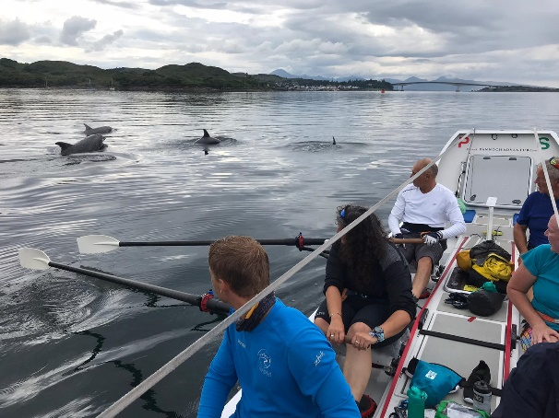
Dolphins ahoy

As with previous legs there was a growing realisation this sport was tougher than anticipated, three hours of rowing to exhaustion followed by cramped accommodation, dried food and poor sleep. Again I was watch leader with Sarah and Jules in the A-Team. Thankfully some of my previous two weeks experience helped them settle in and we worked well as a team with never a cross word. I was now back in the coffin with just enough room to turn on my side. I was though feeling fitter and stronger and noticing that some of my clothing was a little looser than just three weeks ago.
After a night out, the next day brought increasing head winds and we ground to a halt making no headway. Lobster pots around us were static and the sea state was rising. We had to round Stoer Head and the forecast was not great. A decision was made to start the electric engine and head into Lochinver for shelter. One diehard rower voiced this was cheating but was soon quietened by the rest of a more realistic crew. We had no choice in these conditions and headed for shore and a safe haven.
Lochinver is like so many fishing ports a shadow of its former self. Once a wealthy settlement its docks now look overlarge for its token fishing fleet robbed by factory ships and EU fishing policies. It does though have just about the best pie shop in GB and we feasted on meat and fruit pies and beers in the warm sun. Our wrestle with wind and waves was forgotten as we camped on the village playing field in a yurt provided by the Rannoch team.
The next day dawned warm and sunny and the wind although of course still heading us was light. An early start at 06.30 meant we rounded Stoer Head passed the Old Man of Stoer by mid morning and we were now hugging into the shore to cheat the tide with the cliffs of NW Scotland towering above us.
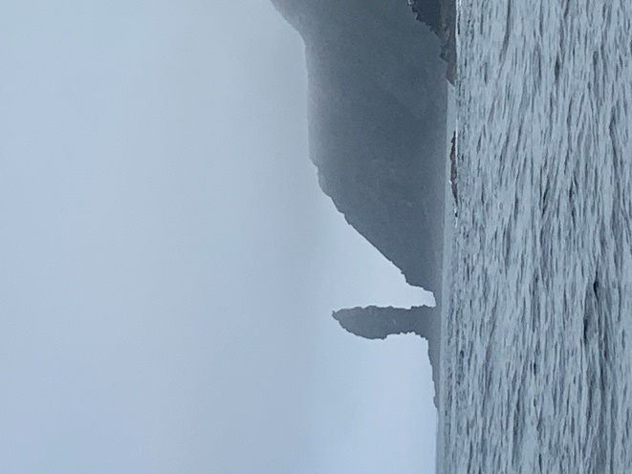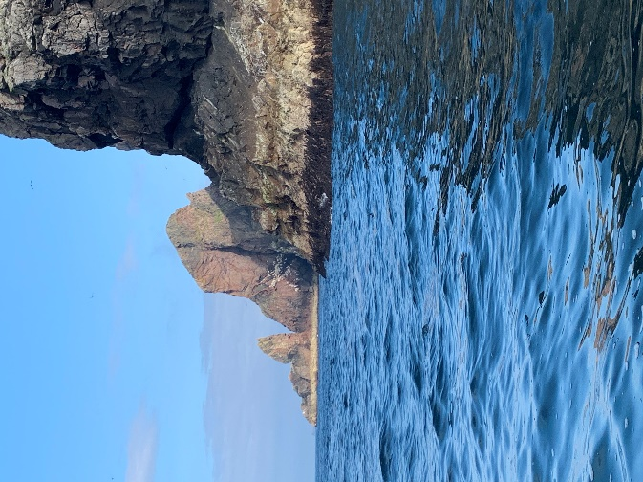
Old Man of Stoer Cape (Not Very) Wrath (ful)

We rounded a very benign Cape Wrath which did not live up to its name and almost for the first time for me there was no north in our heading. But surprise, surprise despite a 90 degree change of course the wind was still ahead, now an easterly. Rowing was good and it was the sort of weather when you could not decide whether to wear wet weather gear or lighter clothing and inevitably ending stripping off layers as you warmed up rowing. What was also inevitable was at the end of a dry three hour row just as you were thinking of a well earned rest a wave would just flop over the side of the boat to give a last minute soaking.
Uncertain whether we would make our way along this northern coast in one leg we made another tide gate and decided to continue to Wick around the corner. We were now facing probably the toughest waters so far, the Pentland Firth where the Atlantic meet the North Sea and is squeezed between the mainland and the Orkney’s. Once into the maelstrom there was no looking back.
Boat speed picked up and Sarah, Jules and I off watch went into our cabin and firmly closed the hatch in case of mishap. We could not see ahead so we were watching the backs of the six rowers and the expressions of Charlie who had taken over manual steering. Speed over the ground notched up and Charlies’ face set firm as he focussed on his course. We passed the previous record of 10.8 knots and moved into 11’s and 12’s finally managing 13.2 knots but by now our east current was meeting the north set of the North Sea with standing waves ahead. Only Charlie could see what was ahead and apprehension turned to concern as his eyes widened. Then we were through, Charlie relaxed and we could open the hatch to congratulate the team on their new record.
Rounding Duncansby Head we imagined Wick about 30 miles ahead would soon be achieved. However, our mean-minded wind god shifted the wind yet again this time to the south and with an adverse tide we made a little over 7 NM over the next 6 hours. Eventually we were in Wick harbour by late evening and then off to our yurt camped in a field outside of town.
The forecast was not great and we needed to wait a few hours until the now south easterly winds eased. It was going to be a tough row across the Moray Firth but we would hug the coast as far as Lybster and then head across to the other side. We left late afternoon and progress was slow. The routine was broken by a radio call from the shore crew asking Rupert if he knew where the caravan keys might be. ‘Oh crap they are in my pocket’. There was no way we were turning back so an hour later Chris could be seen approaching fast aboard a high-speed RIB he had requisitioned to collect them. Rupert took great care to pass the keys across without dropping them. Gradually the night passed as we crossed the Moray Firth and we found the next morning that for the first time we had a true following wind as we headed east.
This was a delight and the novel experience of easy rowing made me realise how different these three weeks would have been with at least some wind assistance. Morale was high and even higher when we were followed by a Minke whale for over an hour. One moment it was ahead and then it would dive and be following astern, then swim under the boat upside down looking up at us as it shot past. A truly memorable moment.
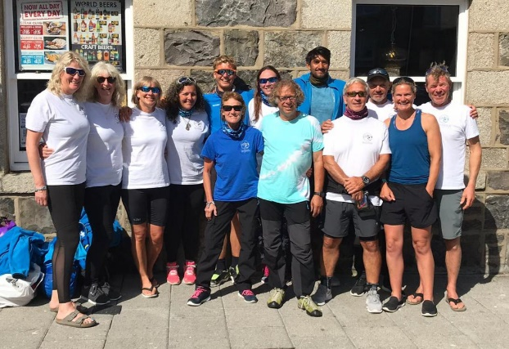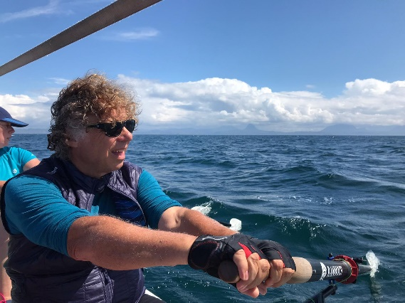
The Allrounders plus Leg 3 Team Last Leg

All too soon this magic day was over and we rowed into Fraserburgh harbour, tied up and made our way to our hotel accommodation and my last night as part of this unique adventure. A last supper and a few drinks then it was aboard a minibus and off the Inverness airport and home to reality after a month away.
Total distance rowed over the three Legs was 674 NM
It was a strange next couple of weeks knowing that Roxy was still completing her quest and I was not part of it. Caroline was though representing SSC on the final tough leg from Scarborough to Burnham on Crouch. We had noticed that they were heading into Shotley for shelter and in true SSC style volunteers ferried them to Manningtree, a meal was rustled up, and beds and sofas found for the night. The final day of the Lionheart Round Britain typified most of the journey with a grim forecast of high winds and rain. The crew set to it and moored to a pontoon off the Burnham Yacht Club literally minutes before the gale hit. Her circumnavigation was complete.
Writing this account some months after the trip, negative memories: the blisters, aches and pains, sleep deprivation and discomfort of the accommodation, those little annoying behaviours of others have all faded. Lasting memories are rowing through the tide-races of Ramsay and Pentland Firth; dolphins, gannets, guillemots, puffins; rowing through the night with stars and full moon or mist; pies at Lochinver; the brutal Bristol Channel; using the bucket in rough seas; the Yurt; cooking, eating and trying to sleep in the cabin; struggling towards Port Ellen and Wick; the following wind and the Minke whale.
Most of all was the companionship, humour and shared endeavour of fellow rowers.
Others who were there too will have different memories and will have had different experiences.
My significant learning is that whatever stage of your life if you want to do it, you can and should
Would I do it again? Well in the immortal words of Steve Redgrave ‘If you see me in that boat again you have my permission to shoot me’. He went on to compete again in the next Olympics and won a gold medal……..
Keith - Lionheart Rower 2021

