Makeda Goes North
Iroquois Catamaran “Makeda”
Skipper: Jerry Garner
Mate: Margaret Garner

Back in January Richard Martin asked me if we had any voyages planned for 2019. I said we were going to head towards the Arctic. He seemed rather astonished but what I meant was "turn left out of Harwich instead of right". In 2017 I wrote a log "A Kentish Man Returns" about a voyage to the county of my birth. This was Margaret's turn; she was born in Northumberland and went to school and university in Newcastle.
Makeda
An Iroquois Mk II catamaran. Built at Brightlingsea in 1969. 30ft long, nearly 14ft beam, twin centreboards. Engine a 9.9hp outboard. She is 50 years old this year and it was also our Golden Wedding in August so this was a double-celebration voyage!

Sunday 9 June HW Mistley 1730
A day later than planned, due to Storm Miguel, we loaded our gear and provisions at the sailing club quay and departed at 1645. One reef in due to the moderate to fresh SE breeze. Berthed in Shotley Marina at 1843. Topped up the water tanks and batteries.
Monday 10 June
Raining! Inshore waters forecast was NE (head wind) increasing 6-7 in north. We decided against starting for Lowestoft today so a second night in the marina. Spent some of the time entering waypoints and route in the GPS as far as Bridlington.
Tuesday 11 June HW Harwich 0646
At 0815 we phoned ahead to Lowestoft (Royal Norfolk & Suffolk Yacht Club) to ask for a berth but were told they were currently full due to all the yachts held up by the weather. Still there is another marina beyond the bridge, if necessary, so we locked out of Shotley at 0900. The wind was S 2-3 but very variable. We had to use a burst of engine to safely cross the approach channel ahead of an incoming ship but by 1015 we were off Wadgate Ledge with "Birdie", our autohelm, steering. We were able to run goose-winged most of the way but the variable wind meant we occasionaly had to gybe. Orford Ness lighthouse was abeam at 1223 and Sizewell power station at 1410. The wind was increasing so we put a reef in the main and part-rolled the jib to give more control in the steep following sea. Southwold lighthouse abeam at 1545. As well as the waves from astern there was a big underlying swell from the NE which didn't help. At 1755 we called RN&SYC on the VHF and they had a berth for us. By 1910 we were moored on the visitor pontoon.
Wednesday 12 June
When I read other people's reports of sailing north from Lowestoft most of them seemed to break the voyage at either Wells or Grimsby. However, both these are a long way off the direct route to the Yorkshire coast. Both options still mean a passage of 20 hours or more and involve strong tides and sandbanks, plus entry to Wells is limited to the high water period. Looking at the chart I realised that the direct route from Lowestoft to Bridlington was only 20 miles further than the longest leg of the Wells/Grimsby options and avoided the problems of the Wash and Humber estuary.
The forecast suggested we would have variable 3-4 at first becoming S 4-5 later. At 0900 I paid for the marina (£32-45!) and at 1005 we cleared the harbour, motoring into the wind towards the Holm Approach buoy. We reached the buoy at 1045, set main and jib and continued close-hauled on port tack. The wind NNE3 and another grey, damp June day. Soon the wind became more shifty and dropped so, to maintain our target speed of 4 knots+, we started the engine and furled the jib. East Cross Sand buoy, our next waypoint, was reached at 1250. Our course was now 340deg, dead into the wind! NE Cross Sand buoy abeam at 1400.
The wind now freshened from NE and we sailed for nearly 2 hours before it became light and variable again. In the early evening the Norfolk coast around Happisburgh was just visible but, before dark, we were out of sight of land with just the Dudgeon wind farm visible ahead. Later we had a close encounter with a brightly lit trawler. The wind filled in about midnight and we were able to continue on a broad reach at 5-6 knots.
Thursday 13 June
Around 0400, with the first signs of dawn, we were still doing 5 knots on a course of 319deg. We were now passing through an area with several gas platforms. A huge swell from the north dwarfing the small waves from the southerly wind.
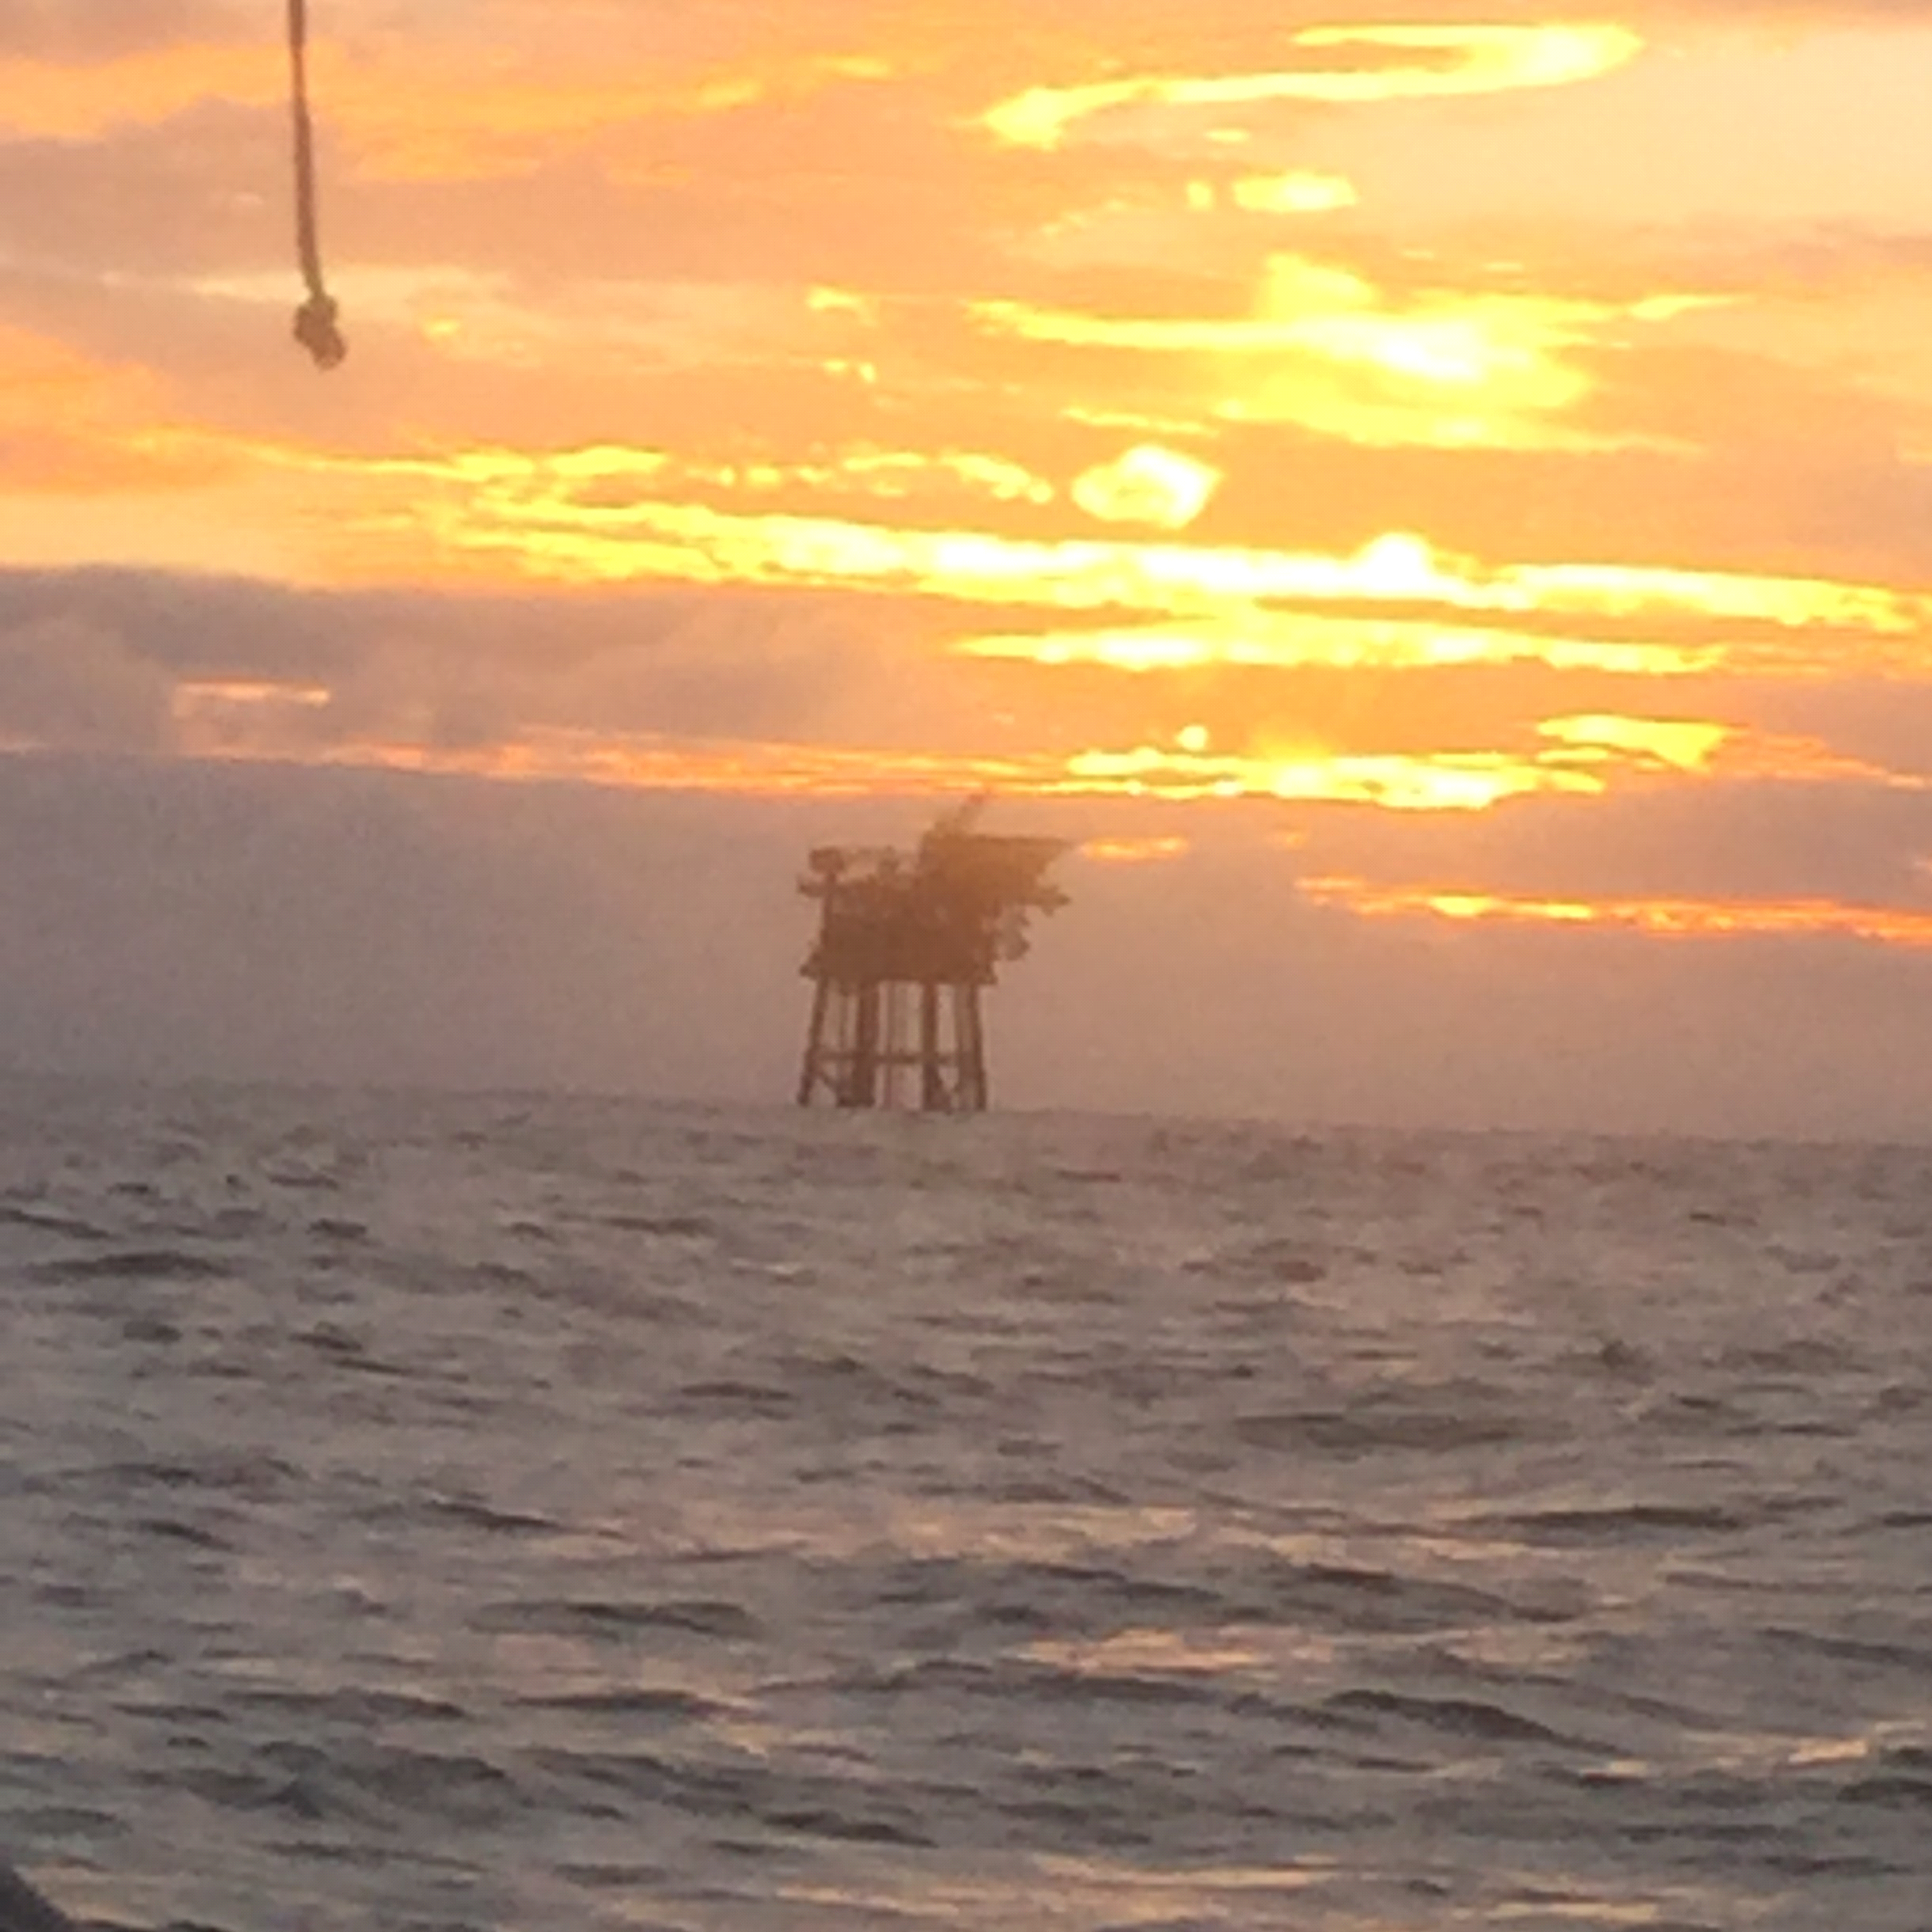
By 0700 we were crossing the entrance channel for the Humber. We passed 2 anchored ships . There were various ships heading in or out of the Humber but none near enough to trouble us.
At 0900 we reached our next waypoint 15 miles north of the Humber. We now altered course to pass inside the Smithic shoal which runs south from Flamborough Head. Mid-morning the wind increased so we reefed and part-rolled the jib.
We tried calling Bridlington Harbour on the VHF but no response so we waited until we were close to the harbour and called the mobile phone number. They asked us to wait for a quarter hour or so for more depth of tide. The 3 visitor pontoon berths were full so we were directed to a drying berth alongside the high harbour wall where we moored, with the help of a man to catch our lines, at 1300.
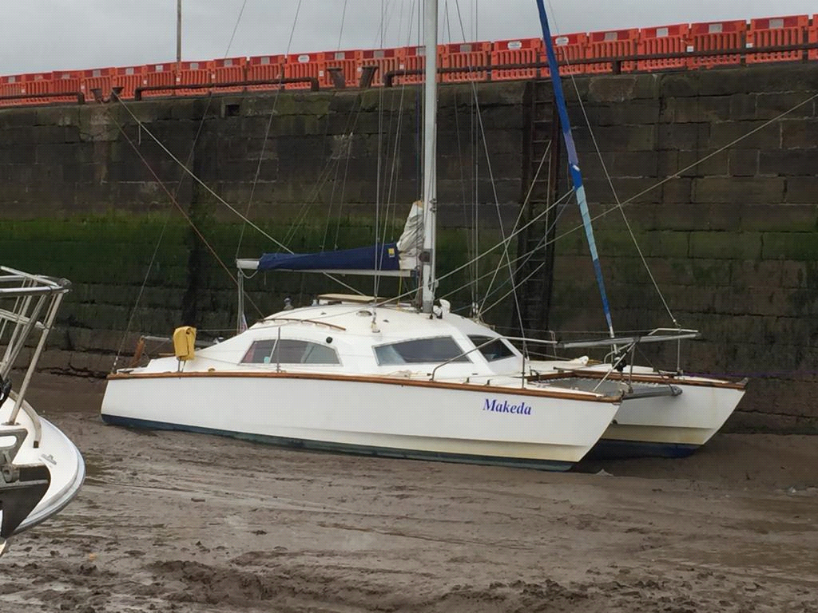
Although not a sophisticated "yachtie" harbour, Bridlington has a special rate for yachts "on passage" of £20 for up to 3 nights (but only once per season, we had to pay the full rate on our return south).
We had a long snooze all afternoon before showering and going to look for the famous fish & chips. However everywhere seemed to be closed after 7.30pm and the weather was cold and grey so we returned aboard for supper and a glass of wine. With a rusty vertical ladder up the harbour wall we would not have risked imbibing alcohol when ashore!
Friday 14 June
We didn't get up until after 8am, the weather wet and cold. We went shopping at Tesco, in the rain. Later went for a super fish & chips lunch.
In the afternoon I emptied our spare cans of petrol in the tank and walked to Tesco to refill them. All that motoring had used a fair bit.
Saturday 15 June
With HW Bridlington at 1630 we either had to leave the berth in the early hours or wait until after lunch. We spent half the morning trying to get a WiFi connection as Margaret had written a poem she wanted to submit for our parish magazine. The harbour info gave a WiFi code but not a title. I tried the code on all the hubs within range with no result. The harbour office seemed to think that the code alone was enough, I don't think they're quite in the digital age yet!
At 1320 we left our berth in the harbour and by 1340 we had cleared "The Canch", a shoal that runs south from the east wall of the harbour. Now sailing with one reef in the main and part-rolled jib.
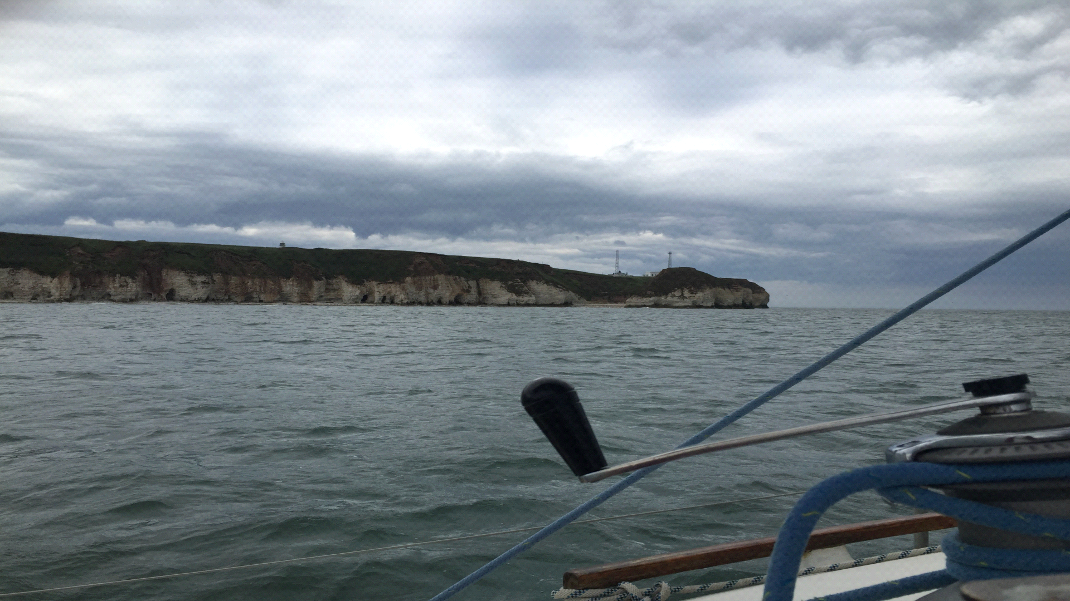
Flamborough Head
The SE wind got very rough and gusty off Flamborough Head so we put the second reef in and bore off for Filey Brigg, which we rounded at 1704. We had picked our way through a maze of lobster pot buoys all across Filey bay and these continued, at a lower density, until Scarborough.
Scarborough also had no spare visitor berths but we were helped to moor on the north wall of the harbour. A vertical ladder higher than Bridlington but in better condition.
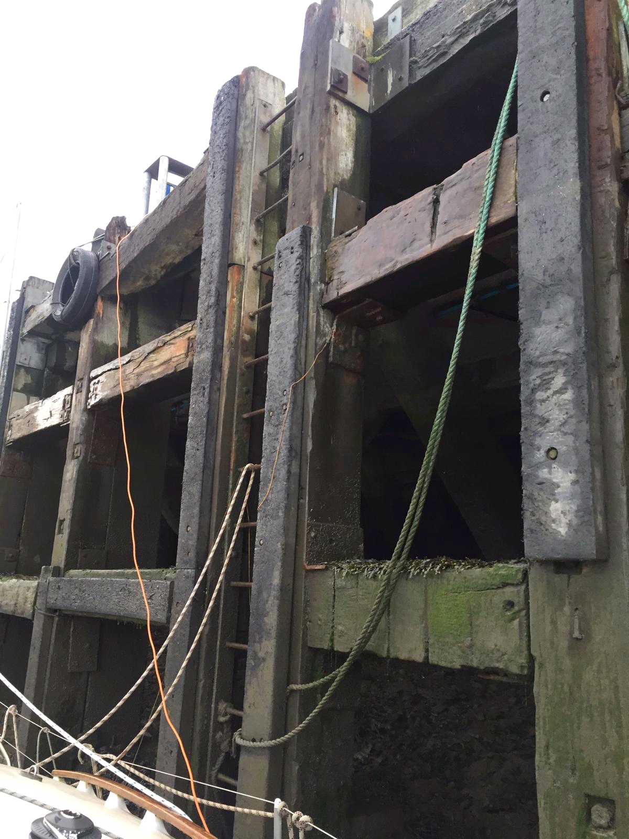
Sunday 16 June
We left Scarborough harbour at 0815. It was sunny but still windy. By 0825 we were under sail, still with 2 reefs and making 7-8 knots before the fresh S wind. Whitby was abeam at 1030, the wind tending to freshen and veer to WSW.
At 1130 we were off the small town of Staithes, about 10 miles NW of Whitby. The length of cliff north of Staithes looks almost man-made: sheer and straight with a chamfered top edge.
By 1300 we were off the Tees. A big industrial area visible and quite a lot of shipping. The weather now showery and gusty. Once we had crossed Teesmouth we called up Hartlepool marina and were advised to follow another local yacht that was going in. Very helpful as the entrance channel to the lock is very difficult to see.
We were moored in the marina at 1445. This is a modern marina within one of the huge docks. Spacious berths and enough spare room for children's sail training in Optimists etc. At the far end of the dock the old frigate Trincomalee was moored by the Naval Museum and a paddle steamer beside the Hartlepool museum. Unlike Bridlington, the marina was well organised for WiFi. They said all the metal masts in the marina caused too much interference so they had a large desk in the marina office with several swivel chairs and plug sockets. In the evening we went ashore for a nice Indian meal.
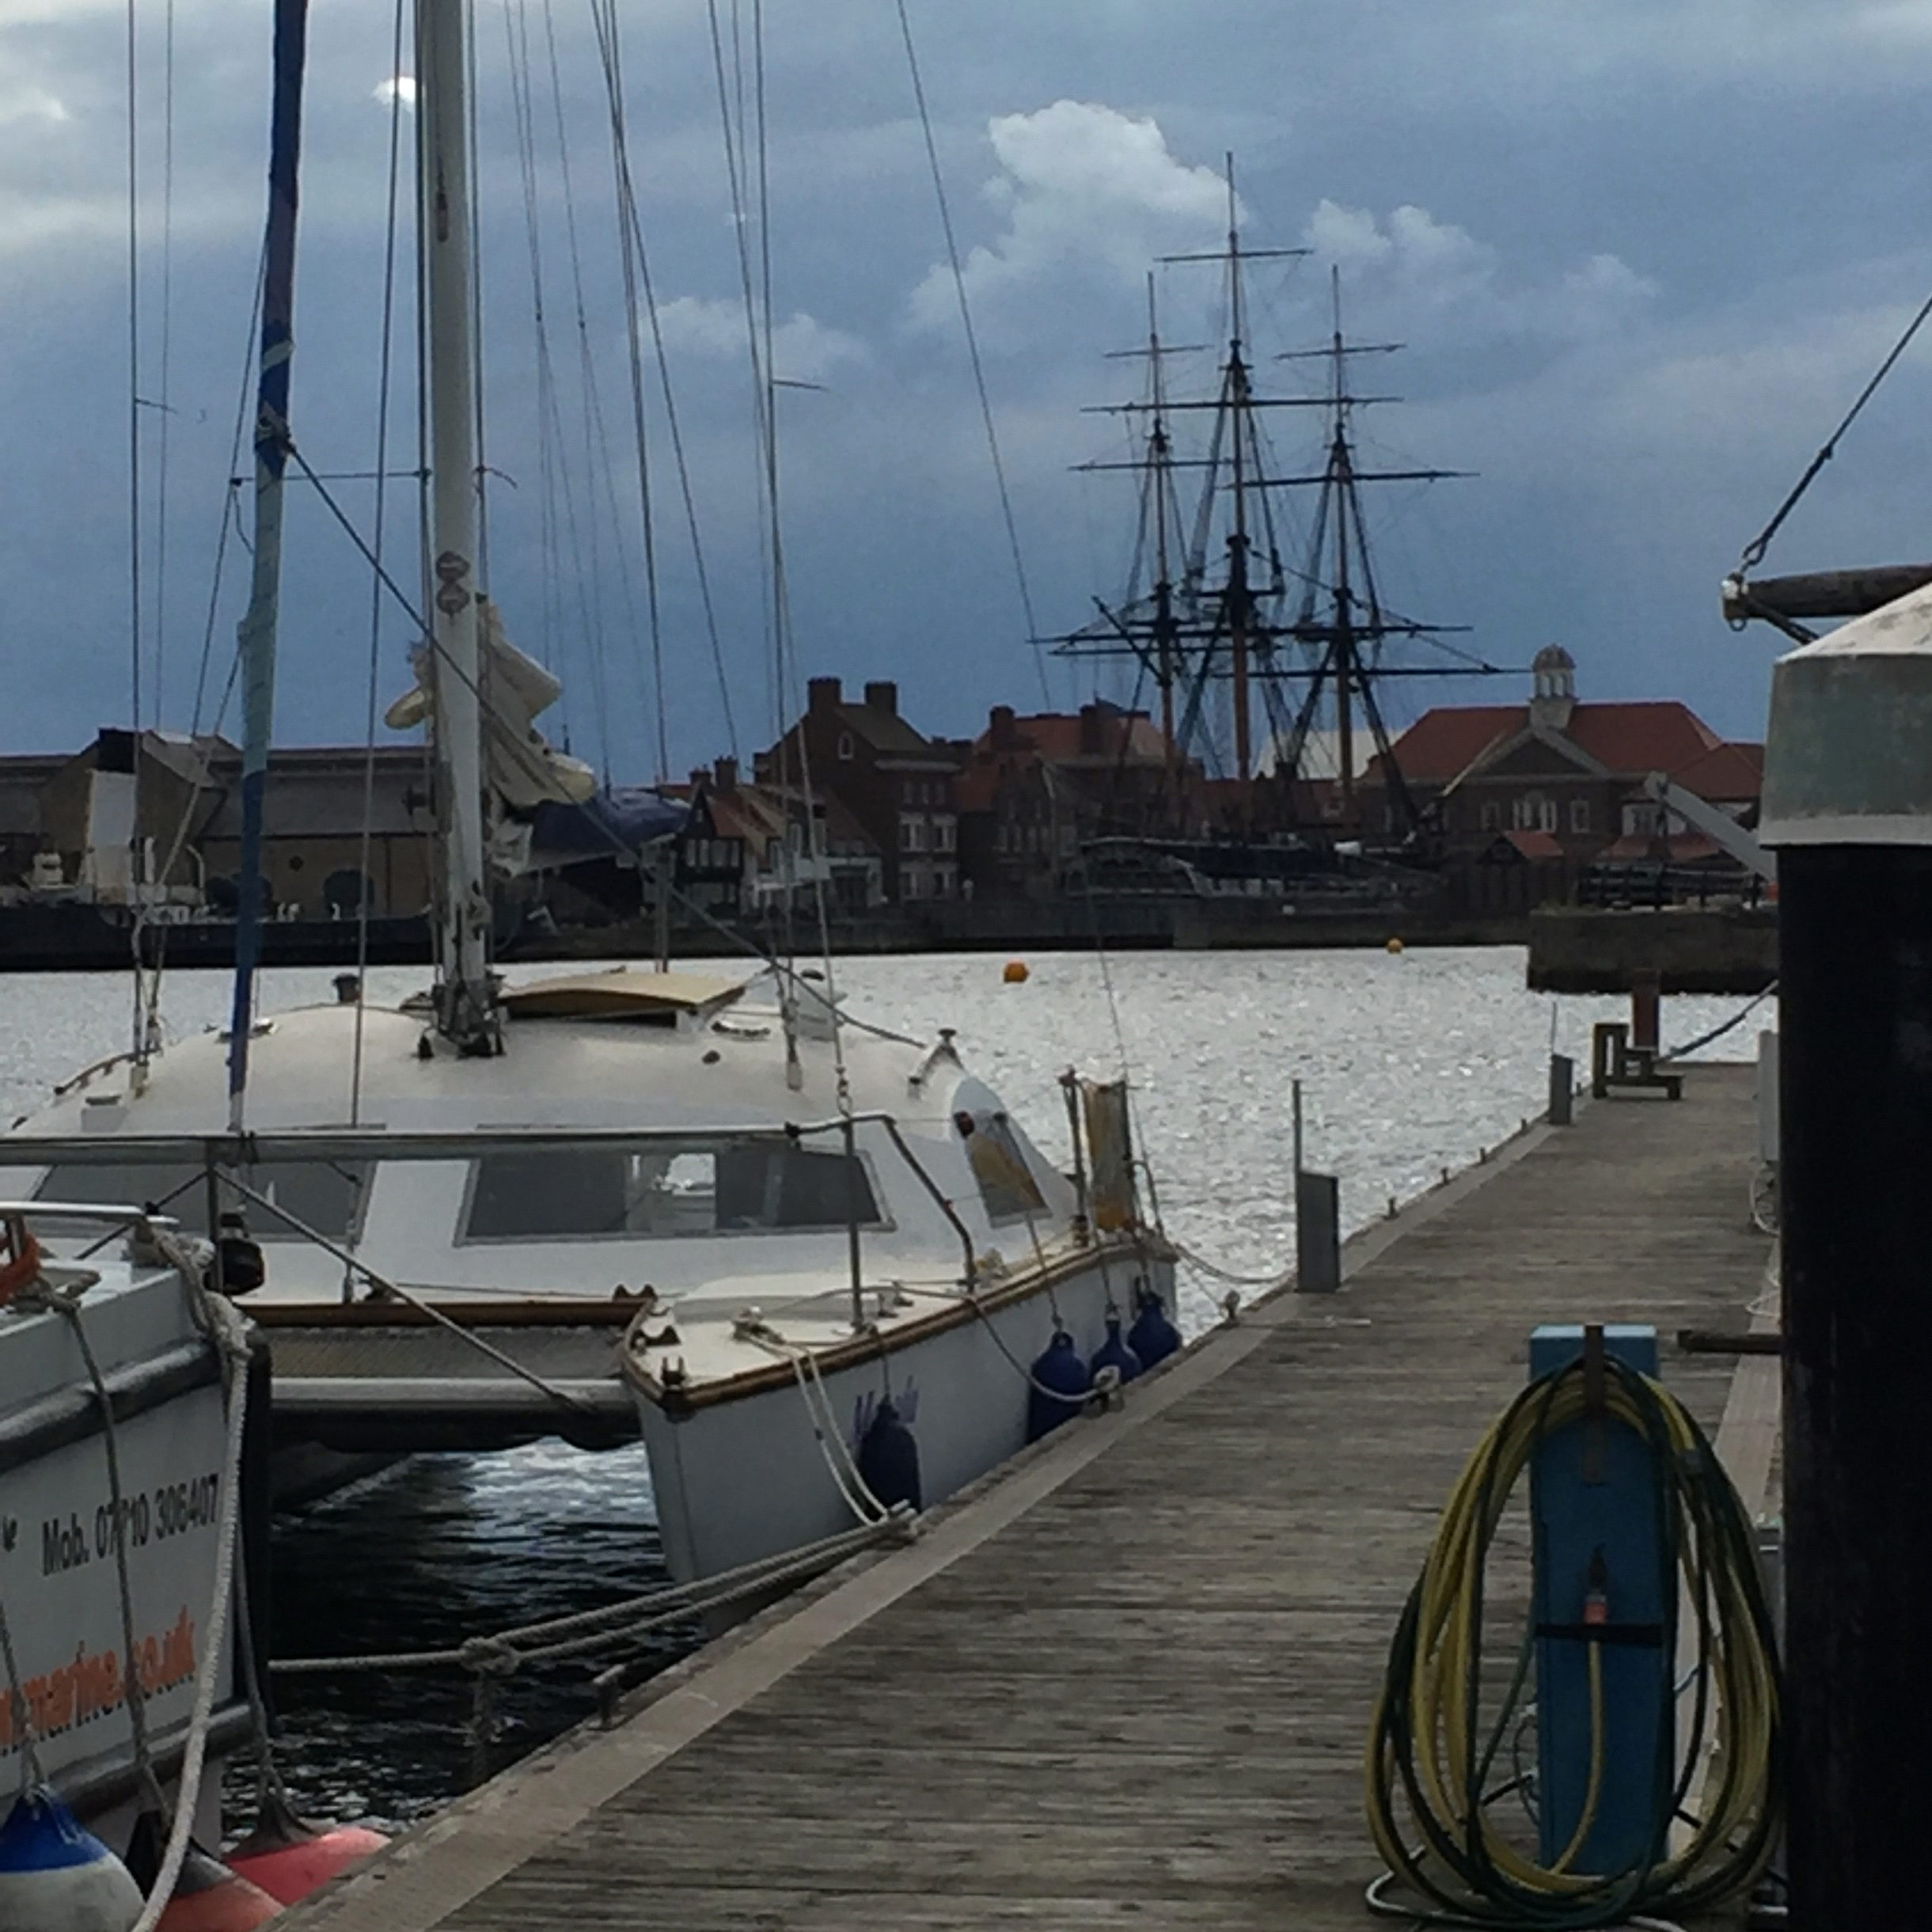
Moored in Hartlepool
Monday 17 June
In the morning we walked to Asda for some shopping, plenty far enough so decided not to lug petrol cans from there. In the afternoon we had an interesting visit to the Hartlepool museum (free, unlike the Naval museum!).
Tuesday 18 June
We cleared the marina lock at 0900 and were soon under reefed sail. Wind SW4+ but sunny. At 1015 we had just passed ahead of an anchored empty oil tanker (the last ship in this north Tees anchorage) when it gave 2 loud blasts on its horn. Perhaps it thought we were terrorists or pirates?
Soon the wind began to ease and we were under full sail until we entered the Tyne at 1221. We called up the Royal Quays marina and were able to lock straight in without waiting. Another spacious marina within a huge old dock. We were moored by 1325. In the evening our son Robert, who lives a few miles west of Newcastle, visited with one of his daughters.
Wednesday 19 June
We paid for our berth (£25-48 for a 30ft catamaran, not bad!) then locked out and stopped at the fuel berth outside to fill our petrol cans. Before leaving, we called Tyne VTS as instructed and were warned of a RoRo ship entering the Tyne. We motored down to the south of the main channel, as the harbour regulations instruct. When we got to the entrance reach, a wide area enclosed by the two long pierheads, we could see the ship was still some way off. I wanted to nip across to the north side so that we could round the north pier without delay. However the pilot boat, returning to the river after putting a pilot on the RoRo, ordered us to remain on the south side. We therefore had to hang around while the ship dawdled into the river and it was not until 1115 we finally cleared the pierheads.
We hoisted the main but had to continue motoring as there was virtually no wind. We were level with Blyth at 1325. Later enough breeze appeared to fill the main and increase our speed by 0.2 knots. Soon we were able to stop the engine, set the jib and run north at 3 knots before a gentle SE breeze.
Mid-afternoon we had a lovely surprise when a school of dolphins came and splashed around us. There were puffins about too.

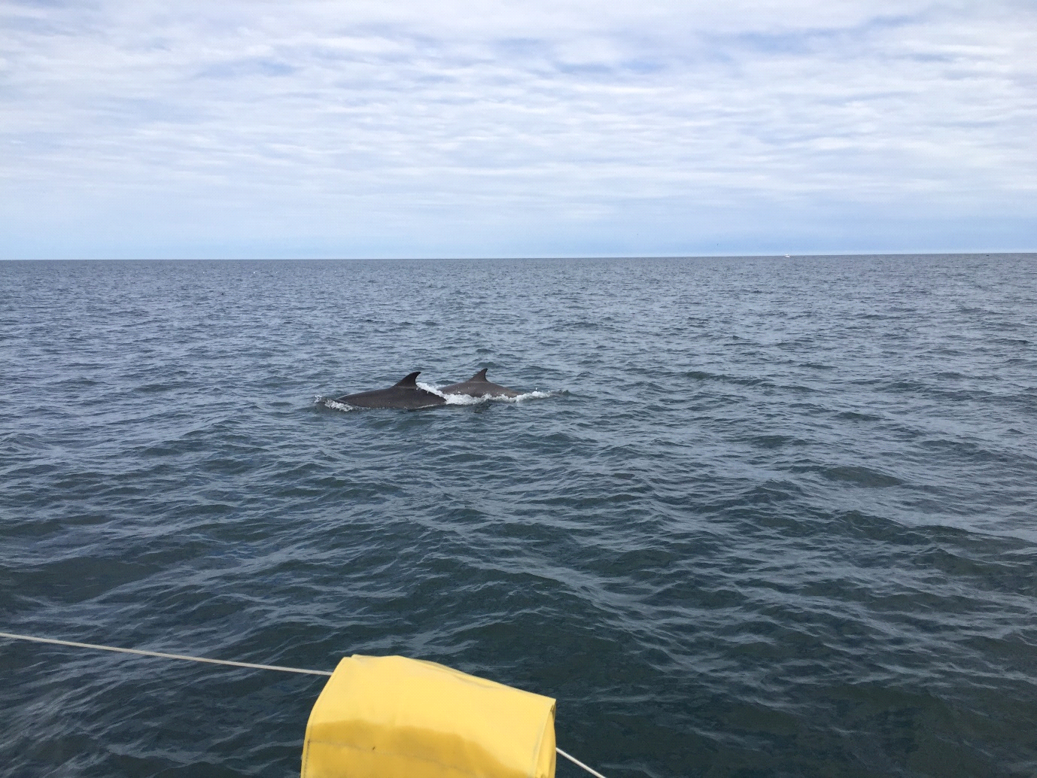
As we approached Amble it was difficult to pick out the landmarks on the mainland mentioned in the pilot book but Coquet Island was obvious enough. The shoal area off Hauxley Point, just to the south, nearly caught us out as we headed for Coquet, from where we could easily identify the entrance buoy and the pier heads. We called the marina on the VHF and were told a berth number and which side to put the fenders. We were moored by 1700 but now the marina office was closed and we collected our “welcome pack” from the fuel pontoon as instructed.
Thursday 20 June
We decided to stay in Amble for a second night so went for a walk along a footpath by the river to Warkworth. We walked round the outside of the castle (£7 to go in seemed a bit steep!) then to a nice little café come art gallery for coffee. There were many birds on the river including mergansers and eider duck. On our return we had a useful conversation with the marina man about the Farne islands and Lindisfarne. In the evening we went for a super seafood meal at “The Fish Shack” on the quay.
Friday 21 June
A sunny but breezy morning. We left the marina at 0900 and once clear of the pierheads set reefed main and part-rolled jib. Wind WNW 5 gave us 7-8 knots at first before the wind headed us and became more variable. Craster was to port at 1035. At 1145 Seahouses was to port and Bamburgh Castle on the port bow.
We had to tack just south of the Inner Farne islands and the smell of bird pooh was noticeable. We rounded Inner Farne and anchored in “The Kettle” at 1250. This was a very sheltered anchorage , enclosed by islands, though a slight swell from the west did cause us to rock a bit when beam on.
During the afternoon there was a continuous procession of trip boats queueing up to land or pick up tourists. There were two mooring buoys near us where the boats waited while their passengers were ashore. The tourists have to pay a fee to land then have to follow a set path round the island before re-embarking. We got a good but more distant view of the birds without paying. The guillemots were packed together like pictures you see of penguin colonies. There were puffins and cormorants on the water all around us. Once the trip boats had finished for the day it was just us and the birds.
Saturday 22 June
After a quiet night, a sunny morning with a light wind. We motored out of the Kettle at 0840 through rafts of puffins. Under full sail we made about 2 knots so after a while we added the engine to boost it to 3. We were at the Bridge buoy at 1000 where we lowered sail and followed the leading marks into the Lindisfarne anchorage. We anchored off Steel End, the point on the west side of a drying bay called The Ouse.
After lunch we rowed the Avon dinghy ashore and carried it well up the stony beach in the NE corner of the ouse. We walked round the eastern half of the island. The meadows were full of flowers including purple orchids. From the northern point we could see Scotland, St Abbs Head but decided not to continue our voyage north as we had forgotten our passports!
We walked back down the eastern side of the island and past Lindisfarne Castle (we had been in the castle on a previous land-based visit some years ago so didn’t go inside). There is a walled garden, designed by Gertrude Jekyll, near the castle, which was interesting. After carrying the dinghy further up above tide level we walked round the village but the only shops were to supply the tourists, nowhere to buy groceries. A tough row back to Makeda about 1600 due to the fresh and chilly SE breeze.
Sunday 23 June
We were under way by 0840 and motored out to the Bridge buoy where we set reefed sails. The wind SE4-5. Off Seahouses, about mid-day, we were able to shake the reefs out and at 1450 we were off Dunstanburgh Castle.
We could not raise Amble Marina on the VHF so we motored in to the fuel pontoon. The marina man was there helping a large motor-cruiser which had a length of discarded warp wrapped round one propeller.
Monday 24 June
We left Amble at 0910. The wind was a light NNW, dead behind us but there were some very big waves between Coquet island and Hauxley Head. As we passed in the lee of Coquet a large number of very annoying flies arrived aboard. An uncomfortable sail, goose-winged in a lumpy sea. Eventually we were able to gybe and reach towards Blyth. We berthed on the Royal Northumberland YC visitor pontoon at 1345.
During the early afternoon there was some heavy rain and thunder but we were snoozing down below. In the evening we went to the RNYC clubhouse which is a very old wooden lightship to pay for our berth (£22-75). Son Robert arrived for a brief visit. His firm has a facility here where they construct the weird equipment he designs for the offshore oil and telecoms etc.
Tuesday 25 June
A filthy, cold, windy morning with poor visibility. We decided to stay another night in Blyth. Late morning we put on hats and coats and walked the 3½ miles into town for some shopping. Noticed estate agent house prices about half those in Manningtree! Mid-afternoon it was raining and blowing harder than ever; glad we stayed here.
The James Cook sail training ketch arrived late afternoon. Later most of the young people from the crew were seen on the pontoon rinsing out small pink buckets; their personal "puke" receptacles!
Wednesday 26 June
By 0930 we had left Blyth and were under sail, doing 7 knots before a northerly wind, one reef in main.
Tynemouth was abeam at 1030. The big waves and northerly wind reminded us of a certain National Twelve open meeting at Tynemouth many years ago!
We had to bend our course round the ship anchorage off Hartlepool but we still got a loud horn blast from one ship; presumably thought we were too close.
We called up the marina – who said “wait for the green light to lock in”. I thought this was on the outer pier then realised we had to enter the inner harbour in order to see a small light on the lock!
We were moored by 1525, on the linear pontoon in the marina. The tightest possible berth; 2ft astern of a 30ft yacht and with our stern line under the bow warp of James Cook which was rafted alongside Faramir, a similar large ketch. Did some shopping and filled water tanks etc.
Thursday 27 June
We locked out at 0820 the wind light SW so we were motor sailing. The Tees wind farm had less than half its windmills turning slowly. Although the wind filled in a bit by mid-morning we continued motoring in order to get to Whitby within 2 hours of HW or they won’t open the bridge.
When we were off Whitby Rock buoy time was getting short as we motored towards the entrance, heeding a VHF warning of diver operations along the east pier. In the harbour we thought we had missed the 1300 bridge opening (they open on ½ hour and hour, 2 hours either side of HW). We were preparing for the waiting pontoon when the bridge VHF said “it’s open if you hurry!” so we were moored in the marina by 1315.
Later in the afternoon we bought 2 cans of petrol (a hard uphill walk to the petrol station). Then, after a rest, did a bit of exploring around the harbour area. In the evening we went for a super fish & chip meal at “Mr Chips”.
Friday 28 June
A dull chilly start to the day but by mid-morning it was brightening up. We put on walking boots and went across the lifting bridge and up the 199 steps to St Marys Church, overlooking the harbour. It still has very Victorian pews with doors and uncomfortable looking seats. Some box pews near the 3 decker pulpit were still labelled for “strangers”.
We went to the abbey ruins but they were closed for the day for some TV filming, the first time ever. We walked on to the cliff head which was a bit like the Naze; earth rather than rock. Then back to the top end of the churchyard, overlooking the harbour entrance, where we ate our sandwich lunch. Returning through the town, we looked into a Jet workshop and discussed this unique jewellery stone with the owner. We were back aboard soon after 1300.
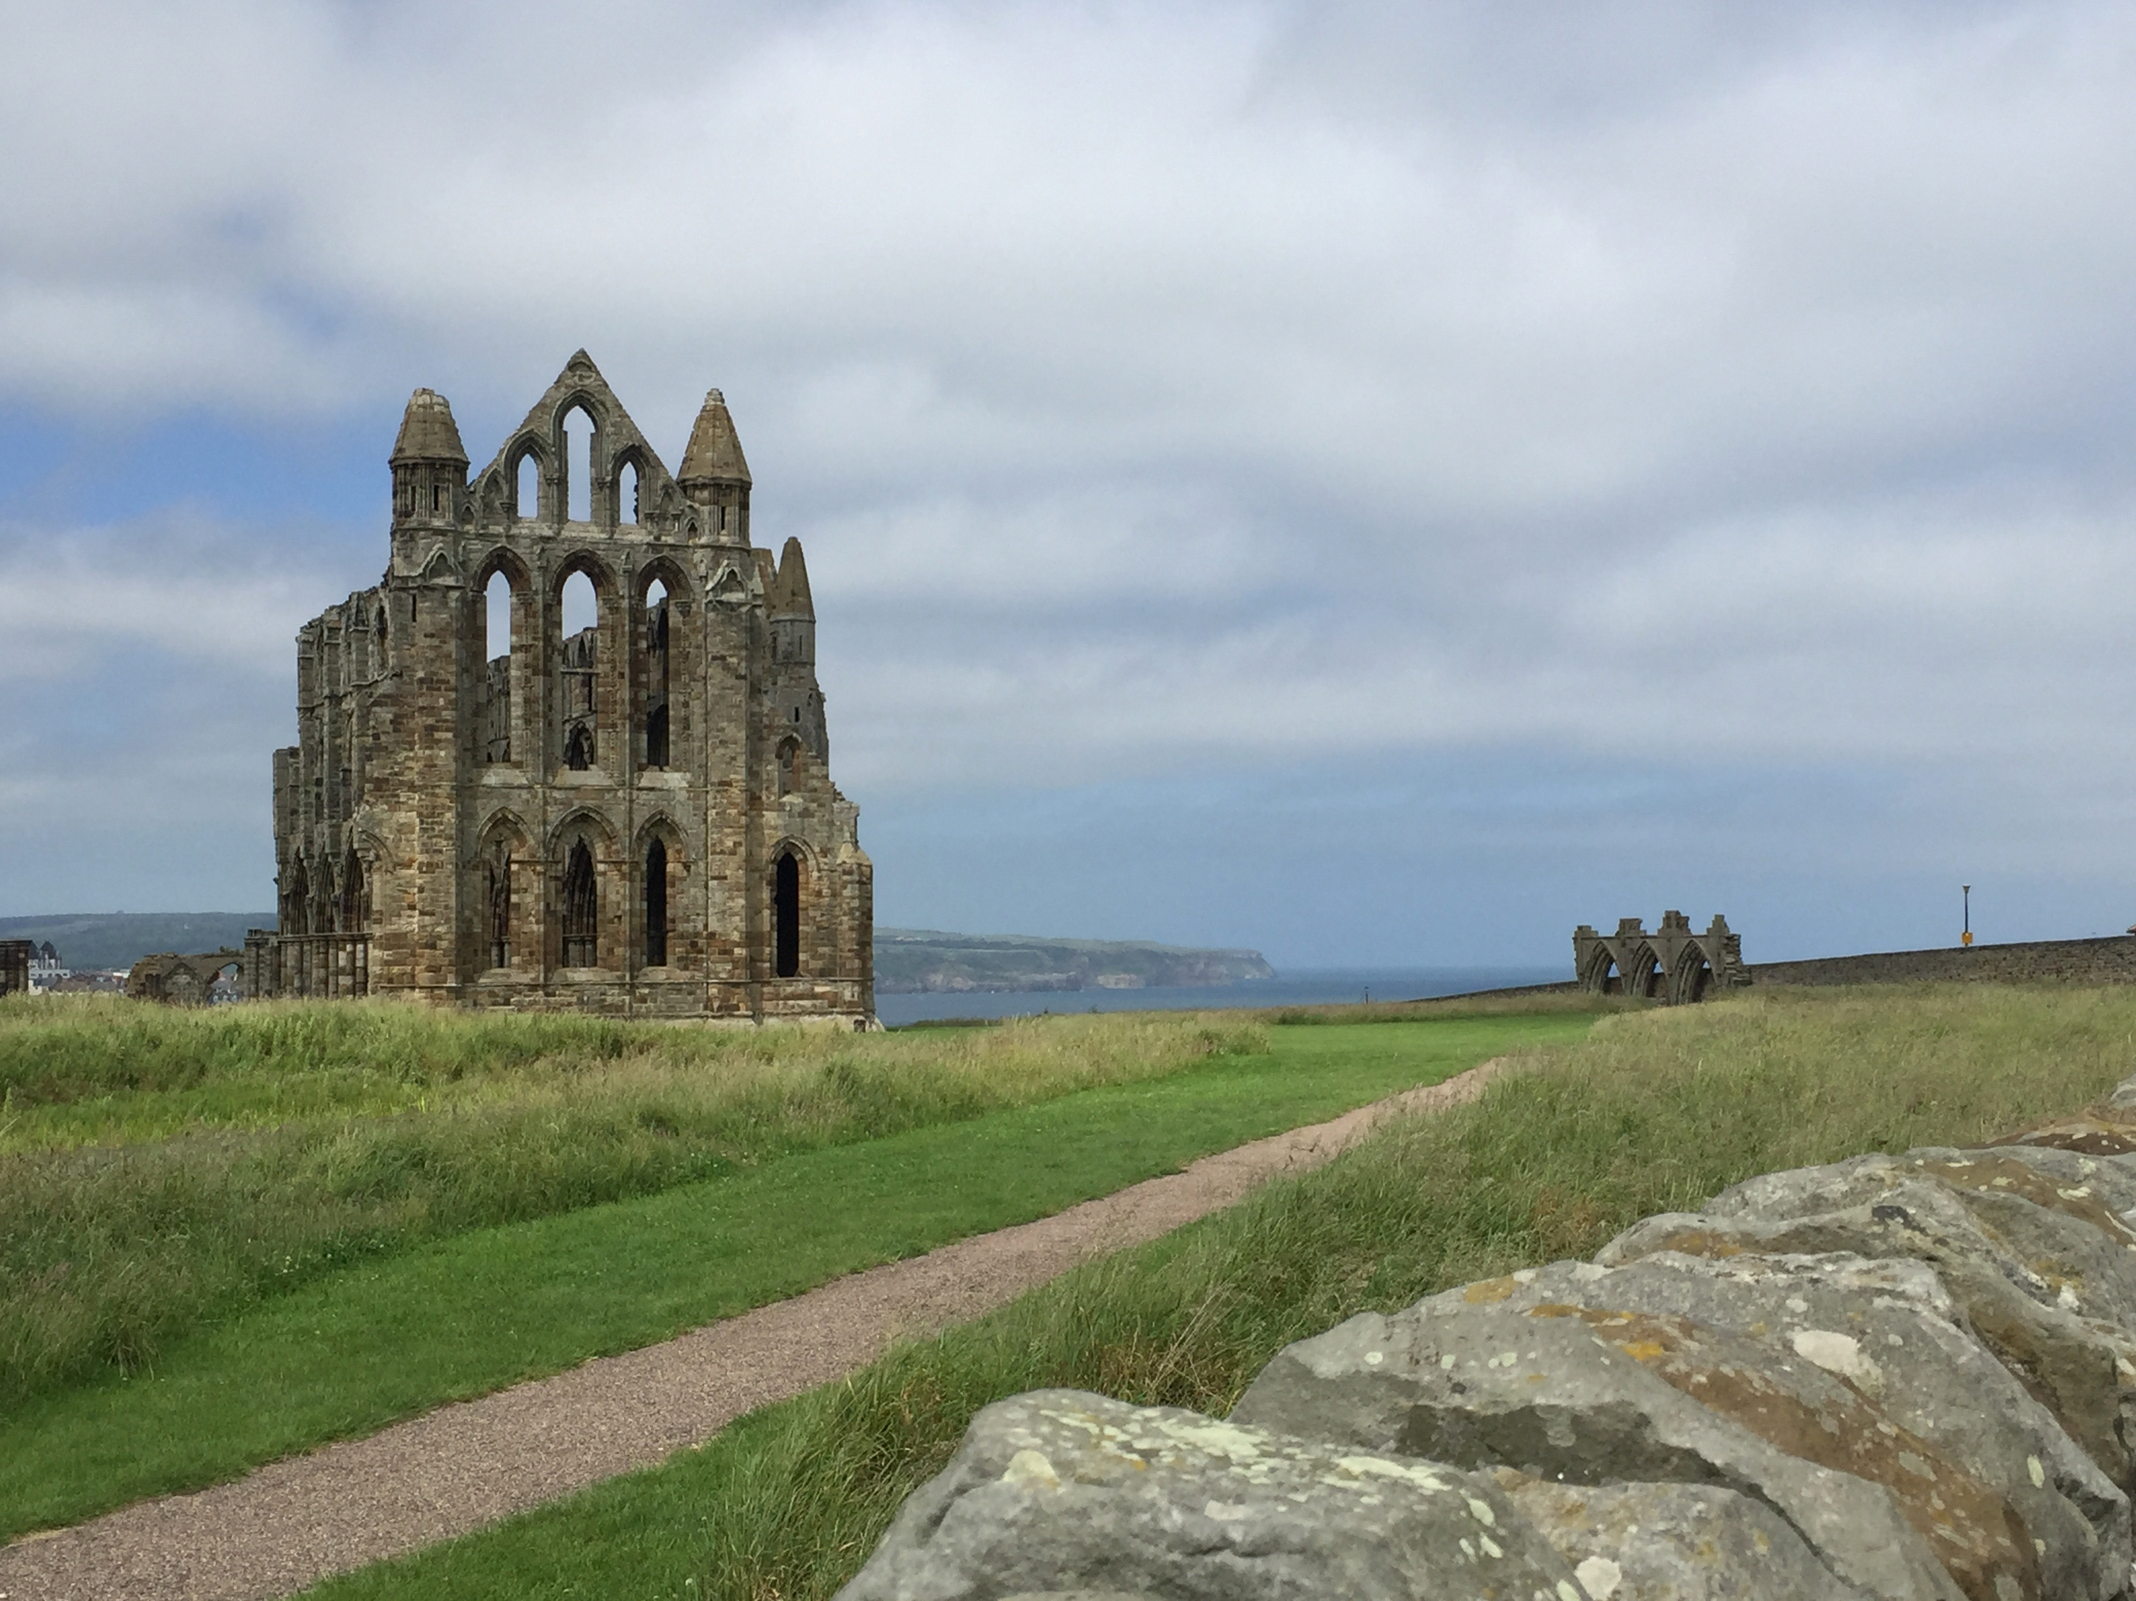
Abbey ruins

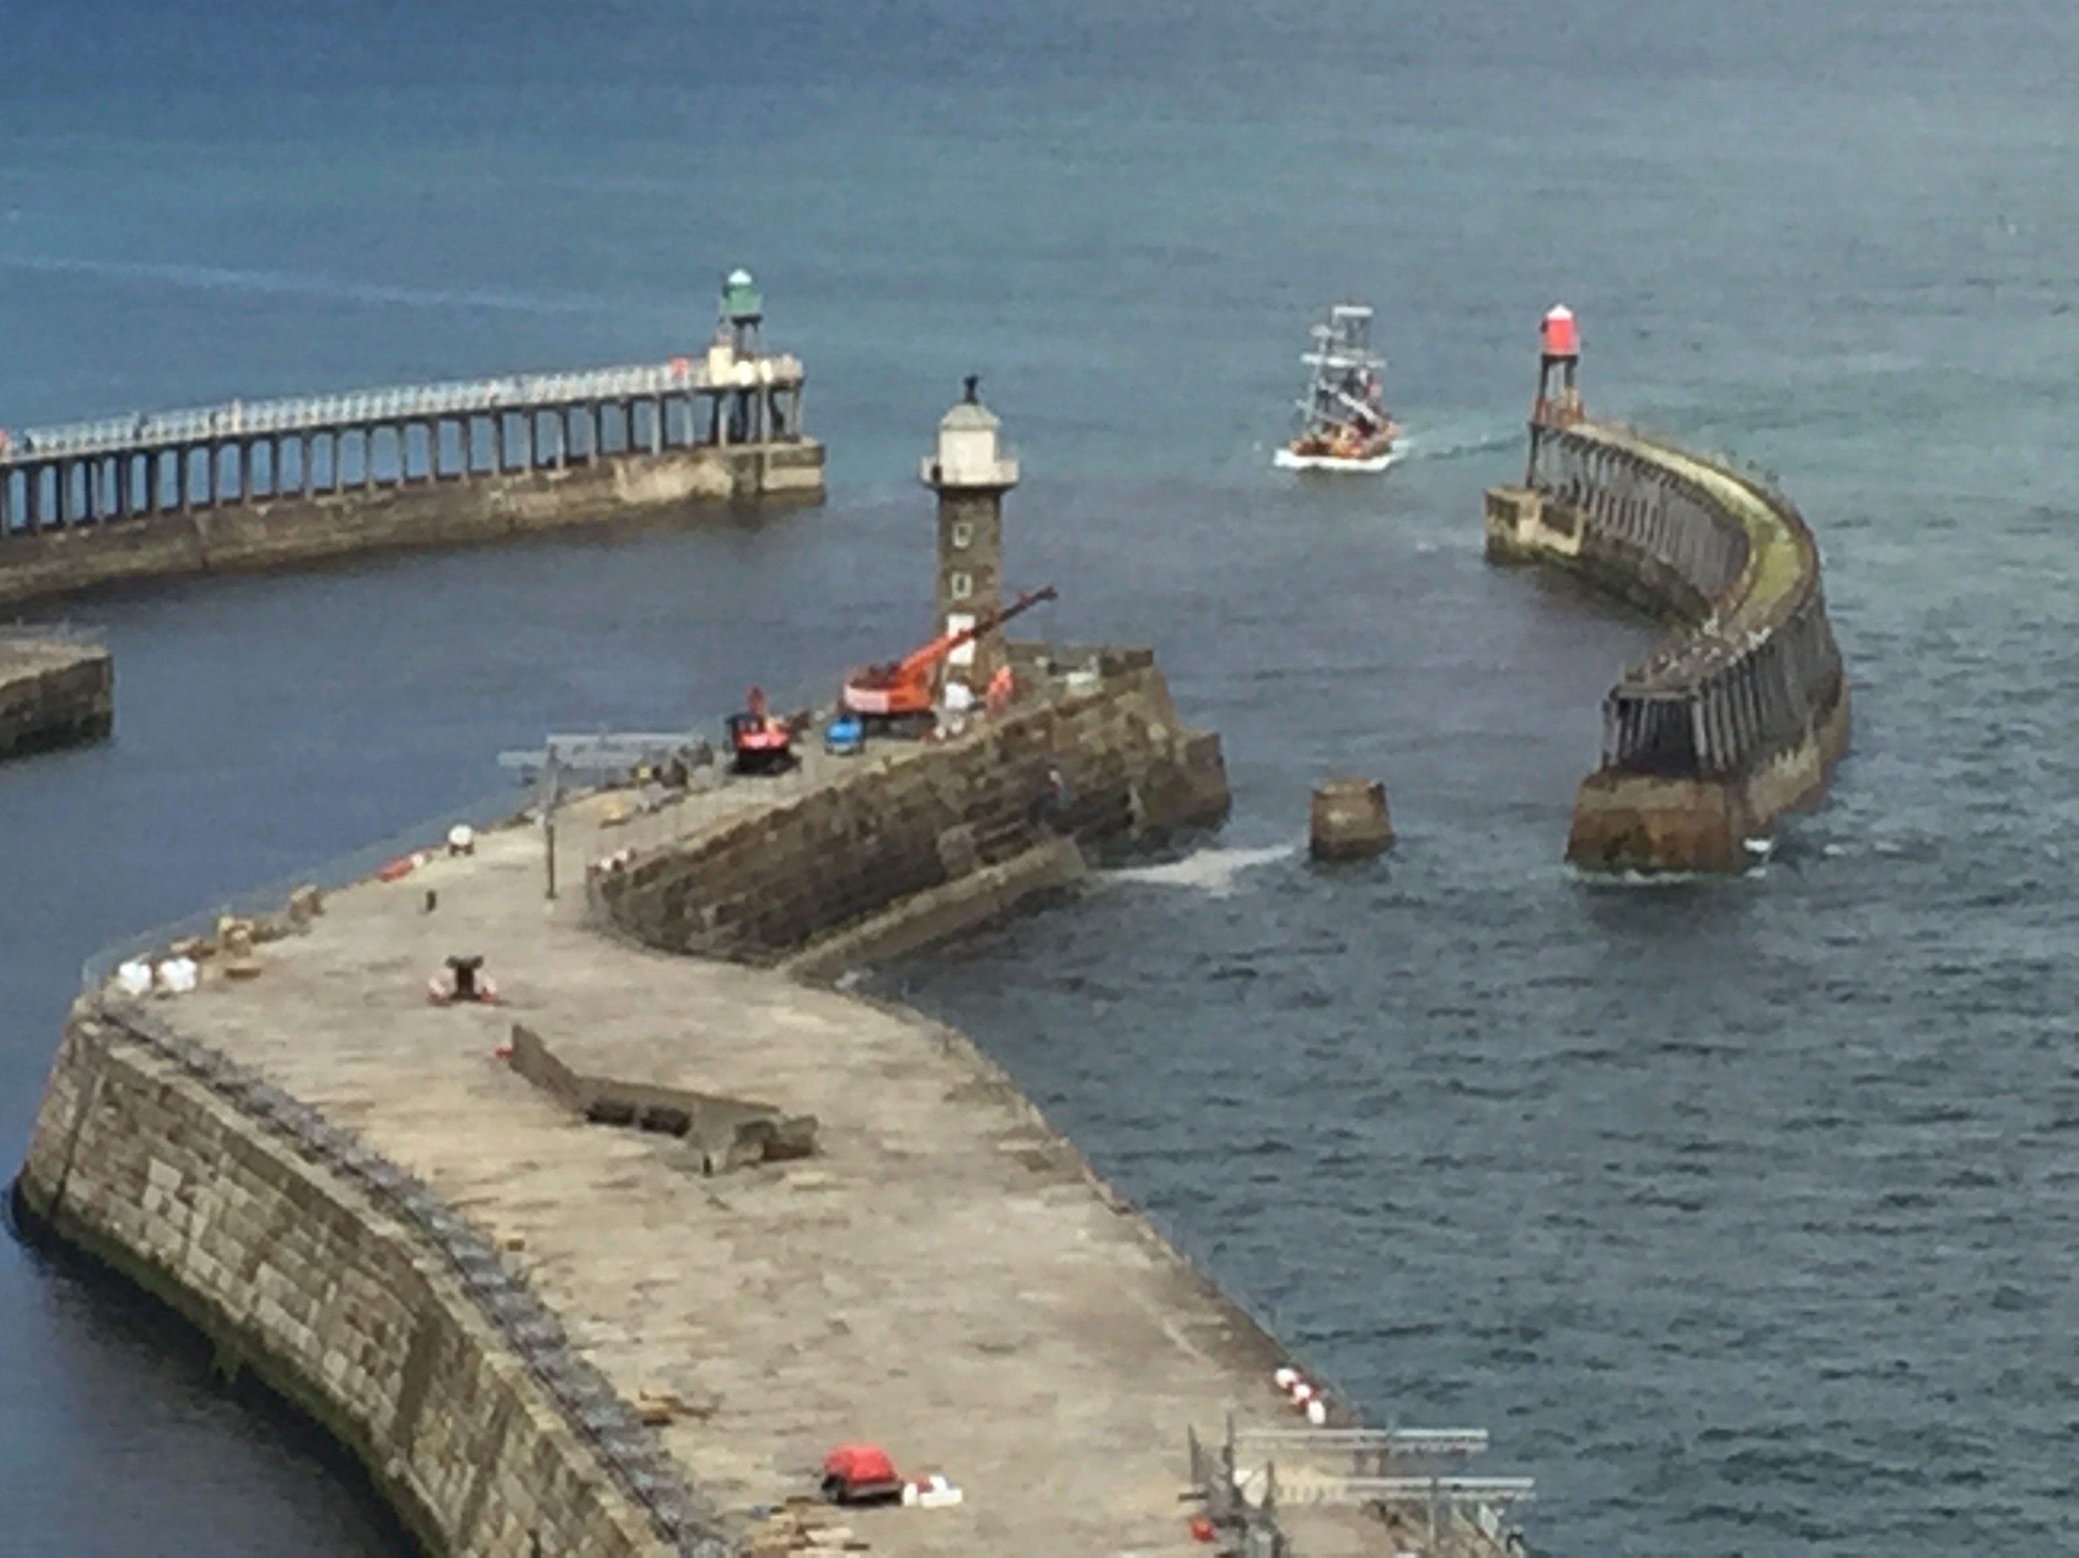
Whitby harbour entrance
In the afternoon we walked up the River Esk to the village of Ruswarp then back over some very steep hill paths. My smartphone recorded a total walking 4.8 miles today but 14461 steps and equivalent of 20 floors!
Saturday 29 June
A sunny morning. Quite calm first thing but by the time we returned from shopping at 0900 it was force 3 SSE. The forecast was for it to veer SW and increase.
This was the most expensive marina since Lowestoft. We were charged 25% extra for being a multihull, the first time this has ever happened and, since we were on a linear pontoon, we were not taking any more space than a monohull of same length. £61-95 for 2 nights!
Being a Saturday there were several yachts wanting passage through the bridge when it lifted at 1200. A bit of a scrum! We motored clear of the harbour and by 1240 were under sail with one reef in.
After keeping well clear of the castle rock at Scarborough we put the engine on to head up towards the harbour. By 1745 we were moored on the linear visitor pontoon in the old harbour. The charge of £24-02 was only 35p more than our mooring on the wall last time here.
Sunday 30 June
A sunny morning with moderate to fresh SW breeze. We discovered that the previous day there had been a large display outside the harbour for "Armed Forces Day" and no vessels were allowed in or out of harbour all afternoon. Just as well we did not arrive any earlier.
Mid morning we went for a walk, via footpath and many steps, to the castle and around its walls. On returning aboard my smartphone had recorded one mile but 22 floors!
We left the harbour just before noon and were soon under sail; one reef in main and half-rolled jib. From there to Flamborough Head we were doing 7½-8 knots with occasional bursts up to 10, the sea fairly smooth. After Filey the colour of the cliffs changed from brown to grey/white. There were large flocks of guillemots and gannets.
We luffed close round Flamborough Head at 1355 and left the North Smithic buoy to port. However, our course slightly west of south close-hauled was taking us over the edge of the Smithic shoal and we had a hard thrash on the other tack through breaking waves, though never less than 8m depth. Several tacks were needed to cover the 5 miles to Bridlington. Possibly the tide eddy south of Flamborough Head was against us.
Engine on and sails off, south of the harbour. We could not raise any response on the VHF except squawks so we motored in and moored in the first pontoon berth seen. The harbour man then showed us a more suitable pontoon berth opposite the wall where we moored last time.
Monday 1 July
A sunny, breezy morning after a good night's sleep. Went to the harbour office and paid for 2 nights (£34-44 cash - no card machines here!). Went shopping, passing 3 charity shops on the way where Margaret bought books. In the afternoon we explored the south beach. The wind WNW 4-5.
Tuesday2 July
We were up at 0450, about high water. The fishing boats had mostly gone already, leaving us a clear path. It was fine, sunny and calm in the harbour. Left our berth 0655 and by 0710 were outside the harbour under full sail; wind NW3. Birdie was steering, doing 5½-6 knots over ground. We passed the SW Smithic buoy at 0738 and bore off for our first waypoint off the Humber. The wind gradually veered to dead astern and fell light. The area of sea to the east of us is labelled on the chart as "california". So now we can say: "When we were sailing down the west of California....."!
At 0935 the wind was so light that we added the engine. Shortly afterwards we passed a large anchored bulk carrier; no visible black anchor ball.
1230 and the sea was glassy with a long swell from the north. Weather overcast. Gas platforms visible to port and Roughs wind farm to starboard, with most windmills stationary. Mate off watch. At 1405 I ran right over a lobster pot buoy! Luckily the twin rudders helped avoid it tangling in the propeller, thought the outboard did kick up slightly.
We carried on motor-sailing right through the night, passing the Dudgeon waypoint at 2212 and North Haisburgh waypoint at 0400 next day.
Wednesday 3 July
At 0535 the engine died, having emptied the main fuel tank. We switched tanks and carried on. Waypoints and course alterations more frequent now as we passed about 10 miles off the Norfolk coast. At 0815 there was at last a breath of wind so we turned the engine off to save petrol. Bore off on a broad reach towards the Holm Approach buoy, making 4-5 knots over the ground. It was finally becoming warm and sunny and there was a general peeling off of clothes, changing into shorts etc. We finally got into Lowestoft and moored at 1130. After lunching we went to bed for a couple of hours.
Late afternoon we took refuse ashore and went to Asda for a few groceries and 2 cans of petrol. During the evening I filled the water tanks. As usual, when the tank was full, I draped the hose over the side while I screwed the cap on. However, our cabin at the aft end of the port hull is the only one with a small opening porthole in the hull, rarely opened unless the weather is really hot. You've guessed it! We later found the hose had nicely soaked my bunk!
Thursday 4 July
We left the harbour at 0830 and by 0915 we were sailing close-hauled in a light SW breeze; making over 4 knots over ground but most of that was tide! We held starboard tack, taking us well offshore. The breeze a bit variable and we nearly got carried on to an anchored ship due to a wind shift and the tide. About 1030 we tacked towards Sizewell, the wind now increasing force 3 and later 4. We beat down the coast past Orford Ness and Aldeburgh and at 1530 were near the Orford Haven buoy.
Until Orford Haven it had been one of the nicest sails so far but now with the tide turning against us it became very frustrating. A friend of ours has a holiday bungalow at Shingle Street and every tack we still seemed to be in sight of Lydia's bungalow! It took us until 1728 to pass the Woodbridge Haven buoy but from here, on port tack, we could just lay our course for the designated yacht crossing to Inner Ridge. It was not to be! Just as we were approaching the crossing the wind started veering until eventually we were heading for Felixstowe beach! A short tack to clear the beach and then we nipped across the channel near the Beach End buoy at 1820.
Anchored above Erwarton Post at 1950 and a seal came to welcome us home.
Friday 5 July
We spent the morning clearing up and packing. An amazing number of books/novels have been aquired on this trip! After lunch we motored up to Manningtree against the westerly breeze. We were amazed to discover two pontoons had appeared since we left. We offloaded our gear into the West Compound, collected our tender and motored back to our mooring.

